

Germany

最新季度特價優惠
FROM 1 July 2009 TO 30 September 2009, HKBWS ENJOYS EXTRA SPECIAL OFFER OF BELOW BINOCULARS OF MINOX.
由2009年7月1日至2009年9月30日以下款型號之德國美樂時望遠鏡，香港觀鳥會會員專享特別優惠，部份型號、只尚餘少量。
Code No. 貨號 | Description  名稱 | List Price (HK$)  零售價 | EXTRA SPECIAL DISCOUNT (HK$)  特別優惠價
優越全功能雙筒望遠鏡
62167 | BV8x42BR | $2,500 | $1,580 36% off
62168 | BV10x42BR | $2,870 | $1,810 36% off
專業雙筒望遠鏡 (非球面鏡)
62128 | BD7x42BR asph | $7,290 | $3,800 47% off
62131 | BD10x58 ED BR | $15,500 | $7,230 53% off
輕量全功能雙筒望遠鏡 (LIGHT WEIGHT)
62147 | BL8x42BR | $5,490 | $3,470 36% off
雙筒望遠鏡 （獨立對焦調校）IF – Individual Focus
62146 | BD6,5x32 IF | $5,500 | $2,850 50% off
高級專業雙筒望遠鏡 (非球面鏡)
62154 | HG8,5x43 BR ASPH | $9,990 | $7,470 25% off
專業單筒望遠鏡 (輕攜型) – Spotting Scope
62225 | MD50W | $3,230 | $2,400 25% off
高級專業單筒望遠鏡 – Spotting Scope
62213 / 62300 | MD62W ED with  20x – 45x目鏡 | $10,350 | $7,280 29% off
高級專業單筒望遠鏡 – Spotting Scope+數碼目鏡相機 DMC(結合目鏡、彩色屏幕及數碼相機功能)
62213 / 60644 | MD62 W ED with DMC | $12,050 | $8,460 30% off
數碼目鏡相機 - 高級專業單筒望遠鏡係列專用 – 適用於Minox/Kowa/Leica/Swarovski
(結合目鏡、彩色屏幕及數碼相機功能)
60644/45/47 | DMC | $3,760 | $2,380 30% off

Terms and Conditions 條款細則:
- The Extra Special Offer is for HKBWS Member ONLY and Valid from 1 July 2009 to 30 September 2009。
- Part of the profit will be sponsor to Hong Kong Bird Watching Society。
- This offer is while stock last。The price (list & special) will be changed without prior notice。
- Please fill the ORDER FORM and FAX to or EMAIL to on next page and send it with a cheque (payable to “The Hong Kong Bird Watching Society Ltd”) to Hong Kong Bird Watching Society. Address: 14/F., Ruby Comm. Bldg., 480 Nathan Road, Kowloon。
- For further Products Information, please enter the web site www.minox.com; www.schmidtmarketing.com; www.minox.com.hk or email: infohk@schmidtmarketing.com 。
- In the event of dispute, Schmidt Marketing (HK) Ltd and Hong Kong Bird Watching Society reserve the right of final decisions.
- 此優惠價只適用於香港觀鳥會會員、有效由二零零九年七月一日至二零零九年九月三十日或另行通知。
- 部份收益將作贊助香港觀鳥會推廣觀鳥活動。
- 以上優惠價之貨品數量有限、售完即止。以上價格(零售或優惠)及優惠有效日期之更改、恕不另行通知。
- 請填妥後頁訂購表格傳真至或電郵至，並附上支票（抬頭「香港觀鳥會有限公司」）並寄回香港觀鳥會，地址：九龍油麻地彌敦道480號鴻寶商業大廈14樓。
- 有關產品資料，請進入有關網站查閱www.minox.com; www.schmidtmarketing.com; www.minox.com.hk或以電郵 infohk@schmditmarketing.com聯絡我們。
- 如有任何爭議興華拓展有限公司及香港觀鳥會保留最終決定權。
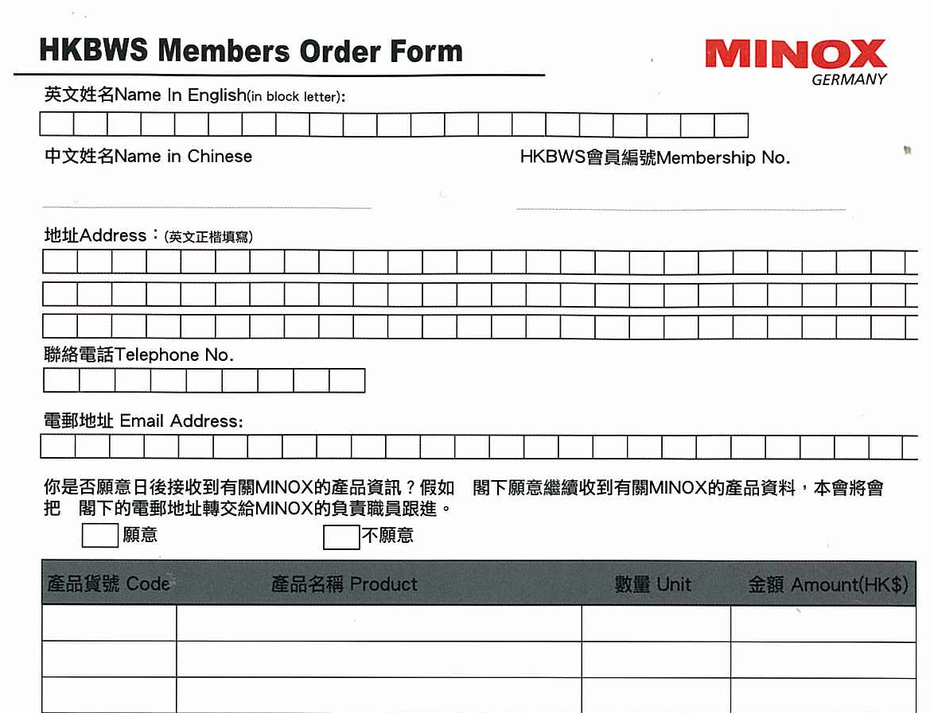
Date 日期: ________________________ 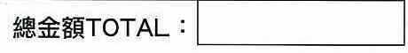

取貨日期Date of Goods Receive: __________________________

會員取貨確認簽署 Member Signature of Goods Receive: __________________________

Terms and Conditions 條款細則:
- The Extra Special Offer is for HKBWS Member ONLY and Valid from 1 July 2009 to 30 September 2009 or further notice。
- Part of the profit will be sponsor to Hong Kong Bird Watching Society。
- This offer is while stock last。The price (list & special) will be changed without prior notice。
- Please fill the ORDER FORM on next page and send it with a cheque (payable to “The Hong Kong Bird Watching Society Ltd”) to Hong Kong Bird Watching Society. Address: 14/F., Ruby Comm. Bldg., 480 Nathan Road, Kowloon。
- For further Products Information, please enter the web site : www.minox.com; www.schmidtmarketing.com; www.minox.com.hk or email: infohk@schmidtmarketing.com。
- In the event of dispute, Schmidt Marketing (HK) Ltd and Hong Kong Bird Watching Society reserve the right of final decisions.
- 此優惠價只適用於香港觀鳥會會員、有效由二零零九年七月一日至二零零九年九月三十日或另行通知。
- 部份收益將作贊助香港觀鳥會推廣觀鳥活動。
- 以上優惠價之貨品數量有限、售完即止。 以上價格(零售或優惠)及優惠有效日期之更改、恕不另行通知。
- 請填妥後頁訂購表格，並附上支票（抬頭「香港觀鳥會有限公司」）並寄回香港觀鳥會，地址：九龍油麻地彌敦道480號鴻寶商業大廈14樓。
- 有關產品資料，請進入有關網站查閱: www.minox.com; www.schmidtmarketing.com; www.minox.com.hk 或以電郵 infohk@schmditmarketing.com聯絡我們。
- 如有任何爭議興華拓展有限公司及香港觀鳥會保留最終決定權。

