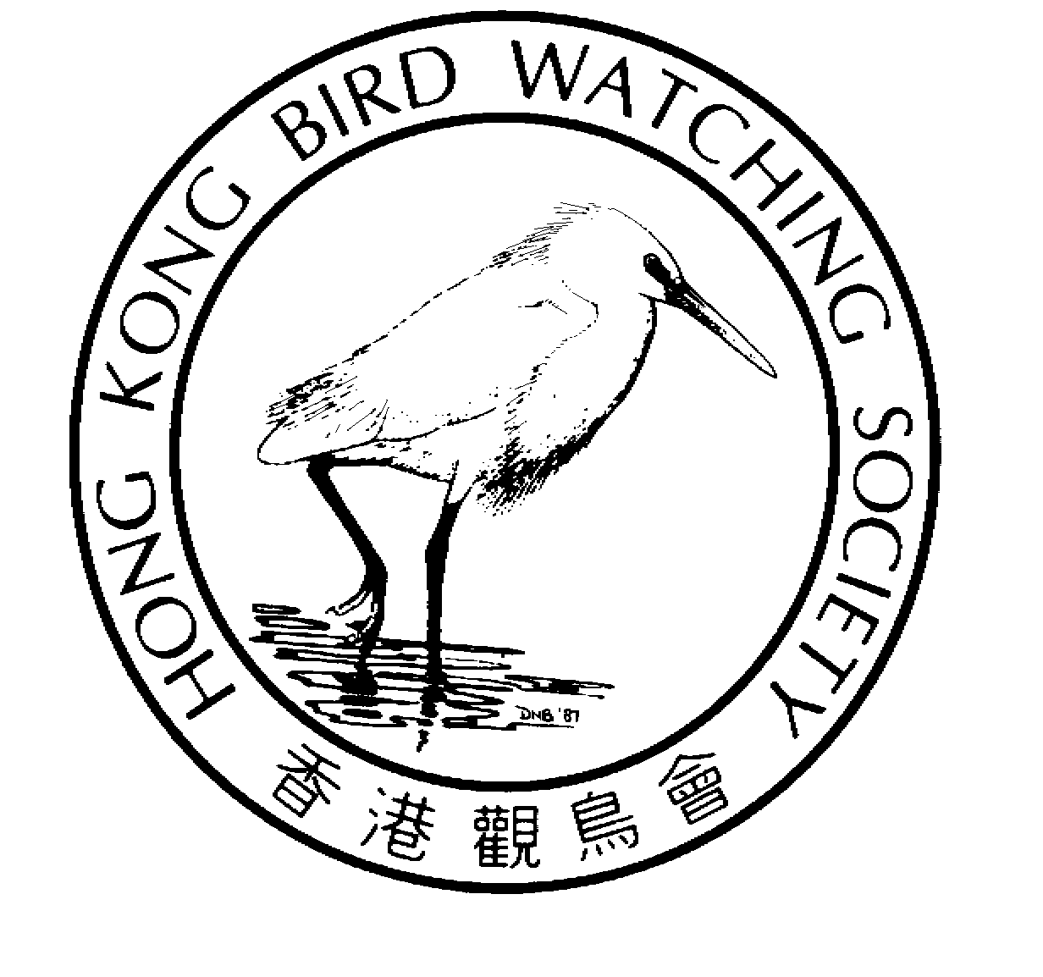
2004 Technical Report No. [your assigned Serial No.]
Your date here [___July 2004]

[Your Title Here]

[Name of author(s) and/or collaborators]
The Hong Kong Bird Watching Society Ltd.
香 港 觀 鳥 會 有限公司
[Insert your cover photo here]
[Your Title Here]

Author
[Your Name(s) Here]
[Name of your Research Group here]
The Hong Kong Bird Watching Society Limited

Data contributors
[Name of contributors]
[Name of contributors, Name of Organization(s)]

Published by
The Hong Kong Bird Watching Society Limited
(Approved Charitable Institution of a Public Character)
BirdLife International Affiliate

The author(s) hereby gives permission to teachers, students, educational institutions, research institutions, conservation organizations and the media to make use of short extracts of the text and also charts in this publication for non-commercial educational, scientific and conservation purpose, provided always that due acknowledgement is given and that a copy of the work containing such extracts and charts is sent to the publisher for record.

Available from
The Hong Kong Bird Watching Society Limited
Room 1612, Beverley Commercial Building, 87-105 Chatham Road
Tsim Sha Tsui, Kowloon, Hong Kong
Tel: (852) 2377 4387 Fax: (852) 2314 3687
E-mail: hkbws@hkbws.org.hk Website: www.hkbws.org.hk

Recommended citation
[Name of author(s) here]. 2004. [Name of this Research Topic]. Hong Kong Bird Watching Society Technical Paper Series: 2004 TR 1, Hong Kong.

Cover photo: [Name of bird] [scientific name (in italic)] at [location of photo taken]
(Photo by: [Name of photographer(s)])

[Your text here. For details of subscriptions, see “Notes to Contributors” (Page 5)]
[Back cover]

The Hong Kong Bird Watching Society Ltd.
香 港 觀 鳥 會 有限公司

The Hong Kong Bird Watching Society founded in 1957, is one of the oldest non-governmental organizations in Hong Kong. It is committed to research, education and conservation related to birds and their habitats. The Society organizes long-term bird monitoring schemes, conducts research and education programmes, and promotes appreciation and understanding of birds within the community. It was incorporated in 2002 as a limited company and was at the same time approved as a charitable organization of a public character. The specific objectives of the HKBWS are:

(a) To promote the study of birds to understand their biology and ecology;
(b) To promote the appreciation and understanding of birds;
(c) To promote the conservation of birds, wildlife and their habitat; and
(d) To promote awareness and observance of laws protecting birds and in particular the Wild Animals Protection Ordinance.

Website: www.hkbws.org.hk E-mail: hkbws@hkbws.org.hk
Tel: (852) 2377 4387 Fax: (852) 2314 3687

Notes to Contributors

1. Reports submitted for consideration should be sent both by post in hard copy (G.P.O. Box 12460, Hong Kong)) and via e-mail (hkbws@hkbws.org.hk) to HKBWS. Please mark “Contribution to HKBWS Technical Report” as subject.

2. The electronic copy shall be submitted in one single file (in MS Word or other convenient format), containing all tables, figures and other illustrations. CD-Rom will be required if the file is over 5MB.

3. The author(s) should sign the “authorization letter” and send it to HKBWS by post together with the report hard copy. HKBWS may make copies of the manuscript as a HKBWS Technical Report and distribute to interest parties. The author(s) may also submit the manuscript or papers containing selected contents to Hong Kong Bird Reports or refereed journal for formal publication or any part of it elsewhere in printed form or other media.

4. The author(s) shall bear all plagiarism and legal liability arising from their report. They shall also be responsible for the quality and accuracy of the contents. Reports submitted jointly by more than one author should have been read and approved by each of the authors before submission.

5. The contents of a report shall be of sufficient scientific interest and shall not contradict the objectives of HKBWS. No personal attack will be allowed. These will be reviewed by the HKBWS before the report is accepted to the HKBWS Technical Reports.

6. A serial number will be assigned to a report when it is first submitted to HKBWS. The serial number will be finalized when the report is accepted after review.

7. Accepted reports will be published in printed format and be uploaded onto HKBWS website in PDF format for public access. Author(s) may also arrange for printing and distribution by themselves.

Format of a HKBWS Technical Report

Contributors are suggested to follow the guidelines below when writing a report:

1. Report Cover
Please use the standard report cover (Page 1 of this report).

2. Text
Consult a recent HKBWS Technical Report for style. The text should have double-line spacing and printed in 10-point Arial font on both sides of A4 paper. Margins should be about 3 cm all round. Skip one line between sections.

2.1 Articles and scientific papers should be divided into the following sections: Abstract, Introduction, Methodology, Study Area, Results, Discussion, Acknowledgements, Literature Cited and, if necessary, Appendices. The Abstract should be within 300 words with 6-10 key words. It should be short and precise, describing the main results of the study. Keep the Discussion brief.

2.2 Short notes and communication include notes on special behaviour, long-term observation of a species, trip reports, etc. Outing reports should at least contain the itinerary and a bird list showing the diversity and abundance of species. Additional notes on interesting observation, bird conservation and weather data are highly encouraged.

2.3 Reports submitted in Chinese should be accompanied by an abstract in English.

3. Tables and Figures
Tables and figures with full captions should be integrated into the main text, with adequate surrounding spacing. Figures should be clear and accurate. Use graphs with dots or lines. Avoid using shades of gray in maps, pie-graphs and histograms.

4. Photographs
Photographs should be of reasonable quality.

5. Units, Symbols and Numbers
Use SI units, abbreviations and symbols. In the text, use words for integers up to and including twelve. Use 24-hour time system, local time (unless otherwise stated) and a continental date system, e.g. 16.30 h on 26 July 2004.

6. Names of Birds and Other Organisms
Use common names of birds and other organisms whenever possible (use a capital for the first letter of each name) and give the scientific name in italics after the first mention of each species in the main text (or Table) and again if mentioned in the Abstract. Use lower case for group names, e.g. grebes, gulls, bulbuls.

7. Reference to Literature
When quoting literature, give the surnames of one or two authors, but only the name of the first author followed by et al. when three or more authors are involved. Give the year of the publication after the names. For example, Carey et al. (2001).

When referring to an article in a scientific journal give:

a. Names of all the authors with initials
b. The date of publication
c. The title of the article
d. The name of the journal in full, followed by the volume number and the first and last pages of the article.

e.g. P. Alström & U. Olsson. 1999. The Golden-spectacled Warbler: a complex of sibling species, including a previously undescribed species. Ibis 104 (5): 113-117.

When referring to a book or a book chapter give:
a. Names of all the authors (or editors if multiple contributions)
b. Year of publication
c. Title
d. Publisher
e. Place of publication

e.g. Carey, G. J., et al 2001. The Avifauna of Hong Kong. Hong Kong Bird Watching Society, Hong Kong.

e.g. Gu, C.M., et al. 1994. The wintering ecology of Oriental White Stork and strategies for conservation. In: Waterbird Specialist Group of Chinese Ornithological Association (ed.). Waterbird Research in China. pp. 37-42. East China Normal University Press, Shanghai. (In Chinese)

8. References:
a. Carey, G. J., et al 2001. The Avifauna of Hong Kong. Hong Kong Bird Watching Society, Hong Kong.
b. Instruction to contributor of “Waterbirds - The International Journal of Waterbird Biology”

