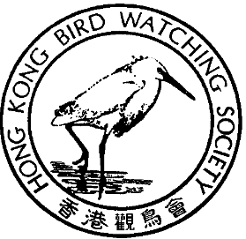

Records 202 – Bird Watching Competition 2004

Programme Detail
Date: 31st Jan (Sat) & 1 st Feb,2004 (Sun)
Time: 4:30pm on 31 January (Sat) to 4:30pm on 1 February (Sun) i.e. total 24 hours.

Enrollment Detail
Eligibility: Each team shall comprise of at least 4 HKBWS members
Competition: To be announced
Fee: HK$200 per team (to subsidize the Society’s expense for the competition, e.g. printing, souvenirs & rental of venue, etc.). Payment method will be informed later.
Method: Please complete the enrollment form below and return to HKBWS by fax (2314 3687) or by email to noah_auk@yahoo.com.hk
Deadline for entry: 19 December 2003
Enquiry: Ms. Joanne AU at 9687 9187 or noah_auk@yahoo.com.hk
Mr. Apache LAU at 9031 1773 or apachewm@netvigator.com

To: HKBWS Project Officer (Fax: 2314 3687)

Enrollment Form
We would like to form a team to participate in the Record 202 – Bird Watching Competition 2004.
Team Name**: |  |  |  |  | Vehicle for team#: (Y) / (N)
Team Captain: |  |  | Contact Tel. No.(M) (H)
Team Members: | 1) |  |  | 2)
 | 3) |  |  | 4)
Team Captain’s signature:
** If you are interested but can’t form a team, please fill in your information. We’ll try to form a team for you.
# Delete the inappropriate

