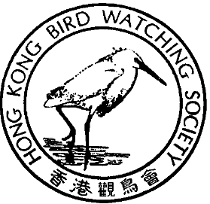

香 港 觀 鳥 會
THE HONG KONG BIRD WATCHING SOCIETY
GPO BOX 12460, HONG KONG. 香港郵政總局信箱12460號

Green Coalition Oppose Threat to Long Valley

in Open Letter to Chief Executive

Groups challenge justification for East Rail Spur Line,
express fear at proposed mitigation

23 June, 2000. Hong Kong Nine Hong Kong green groups, and the Hong Kong University Department of Ecology and Biodiversity have united to protest the gazetted routing of the KCRC Lok Ma Chau Spur Line through the core area of the freshwater flood plain at Long Valley. Delivered on behalf of the Green groups by Dr Ng Cho-nam, Chairman of the Conservancy Association, the open letter to The Chief Executive raises several issues of concern.

Despite recognising the significance of Long Valley as the most important freshwater wetland in Hong Kong, KCRC has, in its EIA, made the unacceptable and unilateral decision that the ecological, landscape and heritage value of Long Valley should be negatively impacted in favour an informal 2004 deadline for completion of the spur line. The groups further believe that a spur line coming from East Rail could be avoided completely if the Lok Ma Chau extension was to branch off from the western end of West Rail Phase II.

“The justification given by KCRC and the Transport Bureau for the construction of the spur line - the short term alleviation of pressure on the Lo Wu Border Crossing due to excessive congestion - is not a railway issue,” said Dr Ng. “So before we even think about changing the alignment perhaps we should consider whether it is worth spending our hard earned taxes on an irrelevant project when other alternatives existed. We appeal to Mr. Tung to direct the KCRC and Transport Bureau to come up with an alternatives that has not damage Long Valley.”

The groups also expressed concern that the fast-tracking process implemented by the Transport Bureau has contravened both internal government procedures and the spirit of the EIA Ordinance. They believe KCRC is taking advantage of the Railways Ordinance to act outside the purview of the Town Planning Ordinance. In regard to the breaching of government procedure, the groups are considering whether to bring this matter to the attention of the Ombudsman’s Office.

40TH

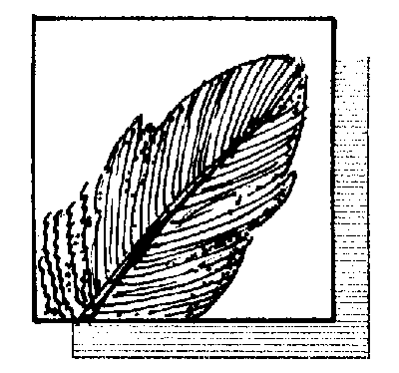

ANNIVERSARY

四十週年

國際鳥盟香港代表
Hong Kong Representative of BirdLife International

EIA reveals serious flaws

“The short and longer-term mitigation proposed by KCRC fails on several counts to ensure a viable future for Long Valley,” said Alex Yau, Senior Conservation Officer, WWF (HK). “Problems emerging from the EIA include the bizarre elongated design of the marshland, which will be restored only when construction is finished. In addition, the EIA report fails to explain how the proposed permanent wetland will be funded and managed in the long term and fails to demonstrate how the wetland will be accessed for management and maintenance purposes.”

Mitigation for the landscape impact of one of the few areas of open country in this part of the SAR is not possible with a 15 metre high viaduct. It will instead be an eyesore which seriously degrades the value of Long Valley as an open area for recreation for the residents of Sheung Shui and Kwu Tung North New Town.

Poor environmental track record of KCRC

“Visits by group members to current West Rail construction sites around Kam Tin suggest that KCRC has been ineffective in minimising damage to the ecologically sensitive habitats, and wildlife, with documented negative impact to trees, fish and birds, including Painted Snipe – a bird known only to breed at Kam Tin and Long Valley,” said Mike Kilburn, Conservation Officer, Hong Kong Bird Watching Society. “From these observations it seems highly likely that considerable damage will be caused to Long Valley during the construction process. Can it be restored? Possibly, but there’s no guarantee, and statistics from overseas is not encouraging. As a result, the coalition has little faith in the ability of KCRC to conduct the construction of the viaduct across Long Valley in a well controlled and sensitive manner.”

Further actions to preserve Long Valley

In addition to presenting its views on the EIA to the Advisory Committee on the Environment, (ACE) whose EIA sub-committee will evaluate the EIA for the gazetted route, the groups are conducting email campaigns petitioning the Chief Executive, the Executive Council and relevant government departments, with the cooperation of leading overseas conservation organisations.

WWF and the Hong Kong Bird Watching Society have submitted an application to rezone Long Valley as a Conservation Area. This zoning application has already provoked preliminary discussions with the Territory Development Department regarding optimising the biodiversity and agricultural heritage of the area. It is hoped that this will prove conclusively to Government that agricultural land has tremendous value for wildlife in Hong Kong, a view which is not officially recognised by the SAR Government.

Ends

For further information please contact:

The Conservancy Association
Dr. Ng Cho-Nam Tel: 2859 7025 E-mail: cnng@hkucc.hku.hk

Hong Kong Bird Watching Society
Mr. Mike Kilburn Tel: 2549 4017 E-mail: mkilburn@hkstar.com
Ms. Carrie Ma Tel: 2377 4387 E-mail: hkbws@hkbws.org.hk

World Wide Fund For Nature Hong Kong
Ms. Alex Yau Tel: 2526 1011 E-mail: wwf@wwf.org.hk
Ms. Karen Woo Tel: 2526 1011 E-mail: kwoo@wwf.org.hk

Friends of the Earth
Mr. Plato Yip Tel: 2529 2777 plato@foe.org.hk

Green Power
Dr. Looking Cheng Tel: 2314 2661 greenpow@hk.linkage.net

Kadoorie Farm & Botanic Garden
Dr. Billy Hau Tel: 2483 9534 E-mail: billyhau@kfbg.org.hk

Green Lantau Association
Lisa Hopkinson Tel: 28930213 E-mail: LisaH@citizensparty.org

Produce Green Foundation
Mr. L.K. Lau Tel: 2304 1685 E-mail: info@producegreen.org.hk

Greenpeace
Mr. Ho Wai Chi Tel: 2854 8355 E-mail: greenpeace.china@dialb.greenpeace.org

Department of Ecology and Biodiversity, The University of Hong Kong
Prof. David Dudgeon Tel: 2299 0600 E-mail: ddudgeon@hkucc.hku.hk

