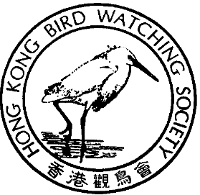

THE HONG KONG BIRD WATCHING SOCIETY
GPO BOX 12460, HONG KONG.

Press Release

Public Consultation reveals heavy opposition to Lok Ma Chau Spur Line

EPD receives “more than 130” written complaints

Hong Kong July 12, 2000. The Lok Ma Chau Spur Line has become the most objectionable project in the history of the Environmental Impact Assessment process. According to EPD “more than 130” individual written objections have been received, including those from private citizens, a number of local green groups, former legislators, and global conservation organisations. This is the most objections received for any project in Hong Kong.

The intention of the project to build across Long Valley and into the Deep Bay Wetland Conservation Area near Mai Po would be in breach of the terms of the Ramsar Convention, which protects wetland areas worldwide, to which China is a signatory. The Head Office of the Ramsar Bureau, the world wetlands conservation body has alerted the Ramsar Convention Implementing Office in Beijing. Wetlands Internationals – Asia Pacific has also voiced its concerns to the Chief Executive, Tung Chee Hua.

In addition, Ross Hughes an expert in the EIA process from BirdLife International stated: “Based on this technical review, I consider that this EIA document contains a number of fundamental flaws which serve to impair the value of the EIA document as a decision-making tool. Therefore, I regret to recommend that the EIA should be rejected.”

Local signatories include The Conservancy Association, Hong Kong Bird Watching Society, World Wide Fund For Nature Hong Kong, Green Power, Hong Kong University Department of Ecology and Biodiversity, Kadoorie Farm & Botanic Garden.

The objections submitted by HKBWS, BirdLife International, Wetlands International and the letter from the Ramsar Bureau can be viewed and downloaded from the Hong Kong Bird Watching Society website at www.hkbws.org.hk

40TH

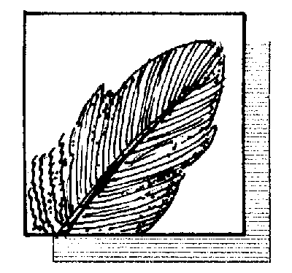

ANNIVERSARY

Hong Kong Representative of BirdLife International

Letter from HKBWS
http://www.hkbws.org.hk/lvalley/hkbws.rtf

Letter form BirdLife International
http://www.hkbws.org.hk/lvalley/birdlife.rtf

Letter from Wetland Internationals
http://www.hkbws.org.hk/lvalley/wetland.html

Letter from Bureau of the Convention of Wetlands (Ramsar Bureau)
http://www.hkbws.org.hk/lvalley/ramsar.html

For further information contact:
Carrie Ma
Hong Kong Bird Watching Society
Tel.: 2377 4387 Fax: 2314 3687
E-mail: hkbws@hkbws.org.hk

Photo: (1) Mike Kilburn, Conservation Officer, Hong Kong Bird Watching Society submitting objections from HKBWS and Birdlife International to the Sheung Shui to Lok Ma Chau Spur Line.
(Download from：http://www.hkbws.org.hk/lvalley/photo2.gif)

Photo: (2) Ross Hughes, Project Officer, Birdlife International and Expert in the EIA during a site visit to Long Valley, which would be seriously damaged by the proposed Sheung Shui to Lok Ma Chau Spur Line
(Download from：http://www.hkbws.org.hk/lvalley/photo1.gif)

