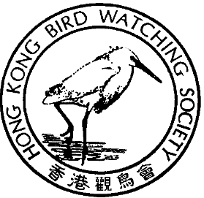

香 港 觀 鳥 會
THE HONG KONG BIRD WATCHING SOCIETY
GPO BOX 12460, HONG KONG. 香港郵政總局信箱12460號

Press Release

Sheung Shui – Lok Ma Chau Spur Line (“Spur Line”)

Letter to members of the Advisory Council on the Environment

14 July 2000. Hong Kong. The Hong Kong Bird Watching Society issued a letter to members of the Advisory Council on the Environment. Followed is the content of the letter:

In the ACE meeting on the coming Monday, the environmental impact assessment report of the Spur Line will be tabled for discussion. As the guardian of the Hong Kong environment you are invited to give the subject careful consideration.

An expert from BirdLife International, Mr Ross Hughes, reviewed the EIA report and concluded that:

“Based on this technical review, I consider that this EIA document contains a number of fundamental flaws which serve to impair the value of the EIA document as a decision-making tool. Therefore, I regret to recommend that the EIA should rejected.”

We would like to highlight a number of points. Firstly, please beware that the executive summary of the EIA report is extremely misleading. The main report contains a wealth of material showing the ecological and landscape value of Long Valley. But the executive summary fails badly to reflect the gravity of the Spur Line cutting through Long Valley and fragmenting the habitat there.

40TH

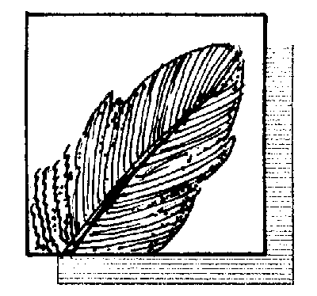

ANNIVERSARY

四十週年

國際鳥盟香港代表
Hong Kong Representative of BirdLife International
1/..2

Long Valley is the last piece of freshwater wetland of some significant size where wet agriculture is still practised. It is the inland analogue of Mai Po, a coastal brackish wetland with gei weis. The proposed alignment of the Spur Line would involve “considerable ecological change”, the duration of which would be “permanent” and the impact of which would be “irreversible”, according to the EIA report itself. This has led to a major outcry of the local public as well as the deep concern of international organizations like BirdLife International, Wetlands International and in particular the Ramsar Bureau, the executive arm of the Ramsar Convention, of which China is a signatory. The Head Office of the Ramsar Bureau, the world wetlands conservation body has already alerted the Ramsar Convention Implementing Office in Beijing about its concerns.

According to the EIA Technical Memorandum, to allow a project to impact adversely on an area of ecological importance, it must be proved that no other practical alternatives exist. Also, adequate mitigation measures are to be employed.

The EIA report has not examined alternatives that would avoid Long Valley. Examples of alternatives to be considered are:

- expanding the immigration/customs facilities at Lo Wu

The Spur Line would be fed by the existing railway between Sheung Shui and Hunghom in any case, a proof that there is no lack of railway capacity on this segment. The fundamental issue we have to address is therefore a matter of providing facilities to bring passengers from Sheung Shui to Lo Wu and processing them quickly there. The number of tracks in this leg could be increased, if necessary at all. This solution would save taxpayers the large sum of money needed to build the Spur Line, some 1 billion dollars we believe.

- building a light rail system

A light rail system could be built between Sheung Shui and Lok Ma Chau, providing stops at villages and Kwu Tung North new town. It would allow greater engineering flexibility, more choices of alignment, more service convenience to local residents and will probably be cheaper.

To allow the Spur Line to rush ahead to damage an irreplaceable piece of Hong Kong’s natural and cultural heritage without due consideration of these and other possible alternatives would be to give up the fundamental principles of the EIA process and to severe our cultural roots too easily indeed.

2/..3

On the mitigation side, the promised wetland creation stands a high chance of failure (around 70%) according to experience elsewhere, even in developed countries like the USA. Furthermore, artificially created wetlands take many years before wildlife communities similar to those they are designed to replace would get established.

The short time frame of the Spur Line project means that there will be practically zero chance for the “temporary created wetland” to provide viable refuge for birds when construction takes place at the heart of Long Valley. There would be zero chance again for the “permanent created wetland” to do the same when the birds are driven out of the temporary so-called refuge once construction advances and overruns it. The mitigation during construction is therefore doomed.

Furthermore, the EIA report provides no future management plan, no managing authority and no funding sources for the created wetland. It reflects a complete lack of commitment on the part of the project proponent to the sustainability of the mitigation. The mitigation in the long-term is also doomed.

We are a small society with no resource to mount any major lobbying effort comparable to that done by the project proponent. However, we believe in reason, justice and the intrinsic love of nature in the heart of everybody. We further believe that as the last line of defense on behalf of the Hong Kong community against intrusions into the environment, you will give Environment and Nature a chance and Hong Kong people a breath of fresh air. We trust that external pressure based on purely commercial interests would not move your determination to protect the Hong Kong environment.

In you, we entrust our future environment.

Yours sincerely,

On behalf of Conservation Committee
Hong Kong Bird Watching Society

P.S. If you would like to see our detailed submission made to the Director for Environmental Protection and the review report of Mr. Ross Hughes, please contact Miss Carrie Ma at 2377 4387 (tel.), 2314 3687 (fax) or hkbws@hkbws.org.hk (e-mail).

3/

