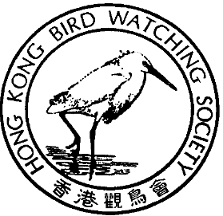

香 港 觀 鳥 會
THE HONG KONG BIRD WATCHING SOCIETY
GPO BOX 12460, HONG KONG. 香港郵政總局信箱12460號

Press Release

ACE advice to government regarding Sheung Shui – Lok Ma Chau Spur Line
applauded by Hong Kong Bird Watching Society

Long Valley spared damage for the time being

The Hong Kong Bird Watching Society welcomes the decision of the Advisory Council on the Environment (ACE) at its meeting today to advise the government that further studies should be conducted to address the major issues raised by the public as well as international bodies concerning the environmental impact of the Sheung Shui – Lok Ma Chau spur line on the conservation, landscape and heritage value of Long Valley, the inland equivalent of world famous Mai Po.

The Society is glad that the value of Long Valley has been recognized and that Kowloon-Canton Railway Corporation (KCRC) and the government have been urged to find an alternative route avoiding the Valley.

International expert Ross Hughes from BirdLife International has described the environmental impact assessment report submitted by KCRC as containing “fundamental flaws”. Academics, including Professor David Dudgeon of Department of Ecology and Biodiversity, Hong Kong University, have also raised serious doubt about the viability of the proposed mitigation measures in respect of damage to the natural habitat.

To rush ahead with the spur line as proposed would have run the risk of breaching Hong Kong’s obligations under the Ramsar Convention for the protection of wetlands, of which China is a signatory. Mai Po and Inner Deep Bay is registered as a wetland of international importance under this convention in 1995.

The Hong Kong Bird Watching Society congratulates ACE members for their determination to avert avoidable attrition of Hong Kong’s environment. The Society will remain vigilant to ensure the long-term future of Long Valley.

- End -

For further information, please contact Carrie Ma of the Hong Kong Bird Watching Society at 2377 4387, by fax 2314 3687 or by e-mail: hkbws@hkbws.org.hk

40TH

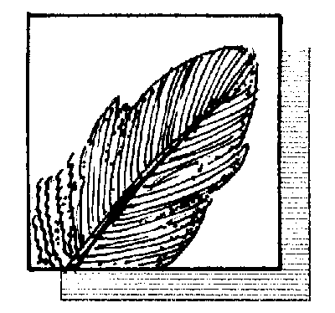

ANNIVERSARY

四十週年

國際鳥盟香港代表
Hong Kong Representative of BirdLife International

