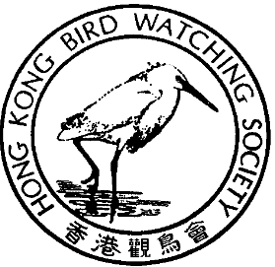

香 港 觀 鳥 會
THE HONG KONG BIRD WATCHING SOCIETY
GPO BOX 12460, HONG KONG. 香港郵政總局信箱12460號

BirdLife International Passes Long Valley Resolution

Calls on HKSAR Government to protect Long Valley as Nature Reserve

27 October, 2000 -- Hong Kong -- The BirdLife International Asia Council Meeting 2000, held in Sri Lanka on 24-25 October, has passed a resolution calling on the Hong Kong Government to ensure the future of Long Valley by declaring it a Nature Reserve.

The resolution follows the landmark decision by the Director of Environmental Protection (DEP) refusing an environmental permit for the KCRC Lok Ma Chau Spur Line. The resolution congratulated DEP, and urged the Government to continue to protect Long Valley under the spirit of the Ramsar Convention and the Environmental Impact Assessment Ordinance.

“This resolution is the strongest expression of international support for the green groups’ campaign and the SAR Government’s decision to save Long Valley,” said Mike Kilburn, Chairman, Conservation Committee, Hong Kong Bird Watching Society (HKBWS). “As a result, Hong Kong’s commitment to protecting its natural heritage has become a model and an inspiration to conservationists and concerned governments throughout Asia.”

HKBWS is one of several local green groups and academics working together to formulate a plan to ensure that Long Valley is preserved. Our vision, which will be announced within the next few weeks, will call on Government to swiftly rezone the Long Valley as a Conservation Area, and also to manage, declare it a nature reserve and provide the resources to manage it accordingly.

“We hope that Government will respond to the resolution by taking the necessary steps to preserve the ecological and agricultural heritage of Long Valley,” added Mr Kilburn. “Our vision is to retain the unique wet agricultural land use, but to actively manage the site for wildlife. This is similar to Mai Po, which is a word class nature reserve that nonetheless retains commercial gei wai and fishpond practices.”

40TH

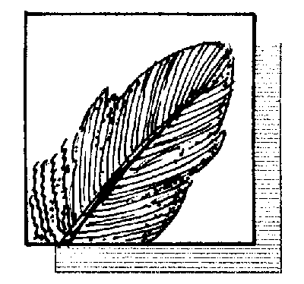

ANNIVERSARY

四十週年

國際鳥盟香港代表
Hong Kong Representative of BirdLife International

Two delegates, Dr Ng Cho Nam and Judith Fruin-Ball, attended the Birdlife International Asia Council meeting on behalf of HKBWS. In addition, delegates from Japan, India, Russia, Malaysia, Taiwan, Nepal, Pakistan, Singapore, Sri Lanka, Vietnam, the Philippines and the Birdlife International Secretariat in the UK attended the Council meeting.

“The Council showed tremendous enthusiasm for the success of the Long Valley campaign to date,” said Judith Fruin-Ball of the meeting in Sri Lanka. “The resolution was passed unanimously, our presentation on the campaign provoked great interest from the delegates, and particular mention was made of the campaign and the government’s decision in both the opening and closing remarks to the meeting.”

BirdLife International has shown great concern and interest in Long Valley, twice sending experts to Hong Kong on fact-finding and support missions. Ross Hughes of the Birdlife International Secretariat and an expert in Environmental Impact Assessments helped prepare a formal objection to the Spur Line EIA, and Richard Grimmett, Senior Progamme Officer for Asia, visited Long Valley a few days before the Council Meeting. BirdLife has committed to continue its support for HKBWS as the campaign progresses.

The Hong Kong Bird Watching Society is a representative member of the BirdLife International Partnership, which represents over 2 million members from over 100 conservation organisations worldwide.

BirdLife is a global Partnership of conservation organisations with a focus on birds that works together on shared priorities, policies and programmes of conservation action, exchanging skills, achievements and information, growing in ability, authority and influence. The BirdLife International Partnership strives to conserve birds, their habitats and global biodiversity working with people towards sustainability in the use of natural resources.

Ends

For further information please contact:

Mr Mike Kilburn Tel: 2549 4017 E-mail: mkilburn@hkstar.com
Dr Ng Cho-Nam Tel: 2859 7025 E-mail: cnng@hkucc.hku.hk
Mr. Forrest Fong Tel: 9480 5233 E-mail: fforest@hkstar.com
Ms. Carrie Ma Tel: 2377 4387 E-mail: hkbws@hkbws.org.hk
