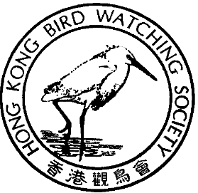

香 港 觀 鳥 會
THE HONG KONG BIRD WATCHING SOCIETY
GPO BOX 12460, HONG KONG. 香港郵政總局信箱12460號

Press Release

SPUR LINE APPEAL CASH BETTER SPENT ON
SECURING FUTURE FOR LONG VALLEY

Hong Kong Bird Watching Society Outlines Alternative Plan for Long Valley

April 6, 2001. Hong Kong. HKBWS today revealed its plans for a Reserve to be established to preserve Long Valley for the long-term future. These would incorporate an already planned TDD Nature Park Area. HKBWS referred to a map (attached) showing the area, which would be protected.

Long Valley is significant for the 29 species of Conversation Importance found there. Of even greater importance is its total bird diversity represented by 210 species and diversity of habitat, rather than special species. The HKBWS plans will preserve the total habitat for all species using Long Valley.

Long Valley is still capable of supporting many of the birds that can no longer use Kam Tin. HKBWS expressed grave concern at the poor performance of KCRC at Kam Tin on the West Rail project. The Society’s Carrie Ma referred to the dumping of construction waste and tree damage, which had occurred on the West Rail project and asked, “Can we trust this company with Long Valley?”

Lawrence Johnstone of the HKBWS Conversation Committee called for Government support for the HKBWS plans for Long Valley saying this would send a strong message of Government commitment to conservation.

The KCRC Appeal against the rejection of its application for an environmental permit begins on 10th April. The Appeal and its reported costs of $20 million are deeply unpopular with the public. A recent public opinion survey carried out by researchers at Chinese University showed that 74% of the respondents supported the decision by the Director of Environmental Protection to reject KCRC’s application for a permit.

(to be continue)

40TH

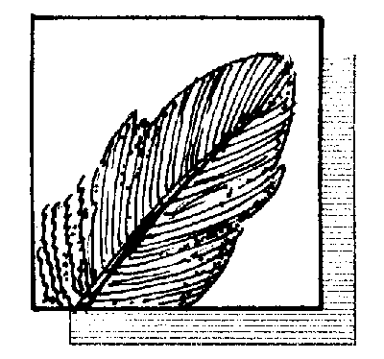

ANNIVERSARY

四十週年

國際鳥盟香港代表
Hong Kong Representative of BirdLife International

(Continue)

“We can only regret that the costs are not instead being invested in plans such as ours to conserve Long Valley for the future” said Lawrence Johnstone.

The outcome of a preliminary hearing regarding new evidence to be brought by KCRC in the appeal is expected shortly. If KCRC are permitted to bring in new evidence which was not available during the statutory public consultation period, HKBWS hopes that new evidence will also be considered as to the presence of significant numbers of the critically endangered Black-faced Spoonbill at Lok Ma Chau. “The EIA Report was seriously lacking in failing to address the impact of the project on the Black-faced Spoonbills at Lok Ma Chau,” said Carrie Ma.

The Society’s legal representative commented that the outcome of the EIA Appeal hearing and the process by which the decision is reached has wide ranging implications for the future of the EIA process in Hong Kong and, indeed, elsewhere in Asia and wherever the EIA process is developing.

- Ends -

Detail information, picture and figures are partly available at:
1. HKBWS Bulletin No. 177 “Save Long Valley II”
2. For download: http://www.hkbws.org.hk/temp.html

For further information please contact:
Ms Carrie Ma, Project Officer
Tel: 2377 4387 E-mail: hkbws@hkbws.org.hk

Mr Lawrence Johnstone, Member of Conservation Committee

Tel: 2526 4694 E-mail: l.johnstone@ifm.org.hk

