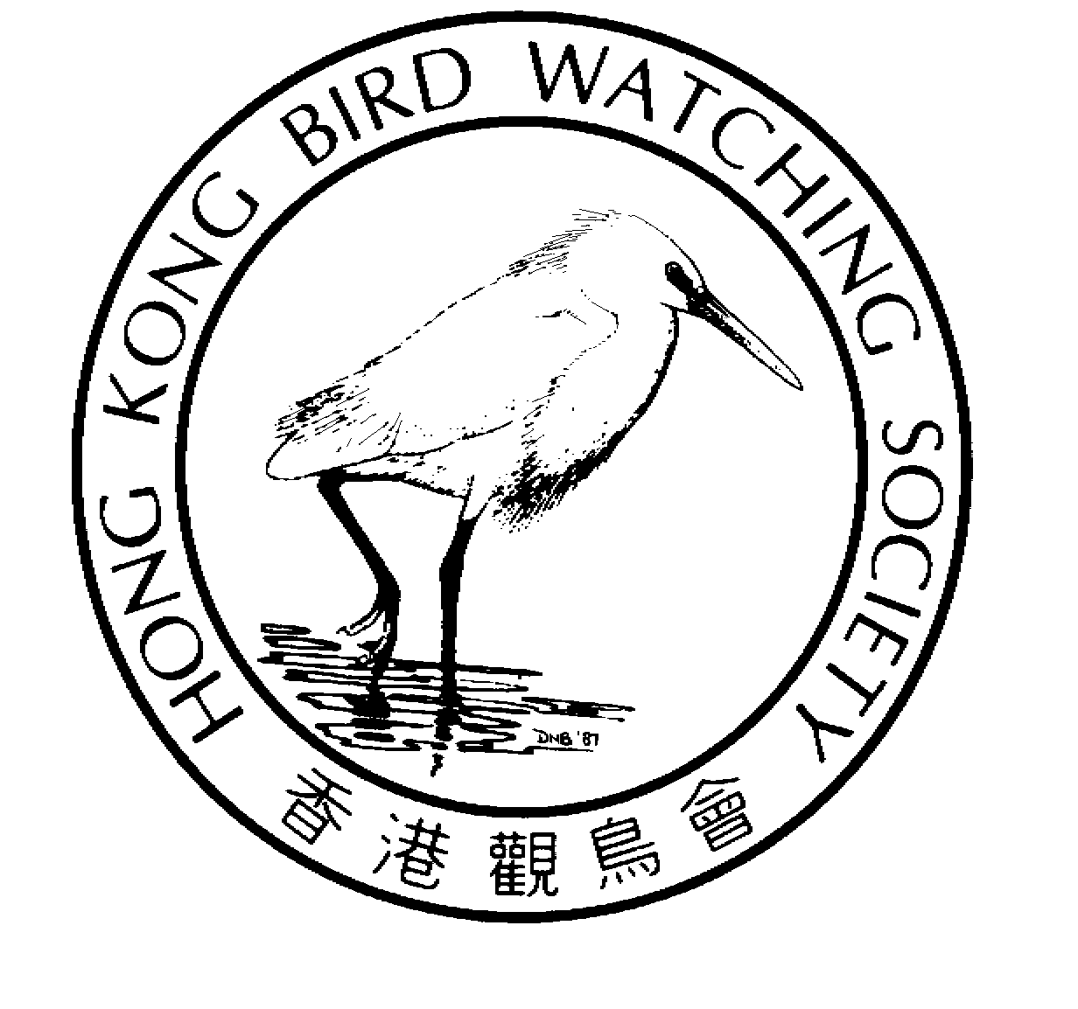
香 港 觀 鳥 會 有 限 公 司
THE HONG KONG BIRD WATCHING SOCIETY Limited
Approved Charitable Institution of Public Character 認可公共性質慈善機構
GPO BOX 12460, HONG KONG. 香港郵政總局信箱12460號

Press Release

Hong Kong Bird Watching Society Publishes “Hong Kong Bird Watching Map”

Partners with Swarovski Optik & HK Tourism Board

to promote bird eco-tourism to international visitors

9th October 2003. Hong Kong. The Hong Kong Bird Watching Society (HKBWS)^{[2]} today published the “Hong Kong Bird Watching Map”, the first guide available at Hong Kong International Airport for visitors wishing to watch birds.

The Map provides visitors with information on 12 of Hong Kong’s premier bird watching sites, including individual maps, information on the special birds of each site and detailed directions on how to find the sites using public transport. In addition to the jewel in Hong Kong’s bird watching crown, the famous Mai Po Marshes Nature Reserve, the Map also covers habitats ranging from forested hills to rocky shores, mangroves, fishponds and farmlands, highlighting the wonderful diversity of Hong Kong’s natural beauty.

Speaking at the ceremony to hand over the map to the Hong Kong Tourism Board’s (HKTB) Product Development Senior Manager Mason Hung, HKBWS Chairman Lam Chiu Ying noted: “HKBWS are proud to partner with the “Map” sponsor Swarovski and HKTB to promote eco-tourism and enjoyment in Hong Kong’s birds and wild places.”

“We welcome this cooperation opportunity between the non-government organisations, commercial sector, and the HKTB in raising interest and awareness of Hong Kong’s ecotourism potential,” said Ms Clara Chong, Executive Director of HKTB.

“As a global sponsor of BirdLife International partnership Swarovski is delighted to partner HKBWS in raising awareness of the top bird watching sites in Hong Kong,” said Eric Hau, SE Asia & Greater China Sales Manager for Swarovski Optik.



The “Map” has already received acclaim from BirdLife International^{[3]}: “ HKBWS have not only created a beautiful and informative guide to Hong Kong’s top birding spots, they have also created a model for co-operation which draws on the particular strengths of different sectors of society,” said Mr Noritaka Ichida, Director of BirdLife International Asia Division. “It is a model we will share with the other members of the BirdLife International partnership. We further believe that birds and their habitat together constitute an invaluable asset for all countries, being an attraction to an increasing number of global travellers.”

In addition to distributing the map to arriving tourists at Chek Lap Kok, HKTB will make it available to tourists at its information centres in town. HKBWS will also distribute copies to teachers through co-operation with the Hong Kong Professional Teachers Union, a long-time partner of HKBWS in raising awareness of birds and bird watching in schools.

- Ends -

For further information please contact:
Carrie Ma, Project Officer
Hong Kong Bird Watching Society
Tel: 2377 4387 (office); 9041 3021 (mobile)
E-mail hkbws@hkbws.org.hk

Notes for Editors
^{[1]} Photograph of birds and bird watching maps is available on the website http://www.hkbws.org.hk/fileServer/Projectofficer/b_map.html. Further information on the birds, and its habitat is available upon request.

^{[2]} The Hong Kong Bird Watching Society is a membership-based organization committed to research and conserve birds and their habitats, and promote the enjoyment of bird watching through monitoring, education and public awareness building, advocacy and community participation.

^{[3]} HKBWS is affiliate of BirdLife International. BirdLife International is a global alliance of conservation organization working to protect the world’s birds and their habitats. BirdLife International is present in more than 100 countries and territories, with a global membership of over 2,500,000.

