
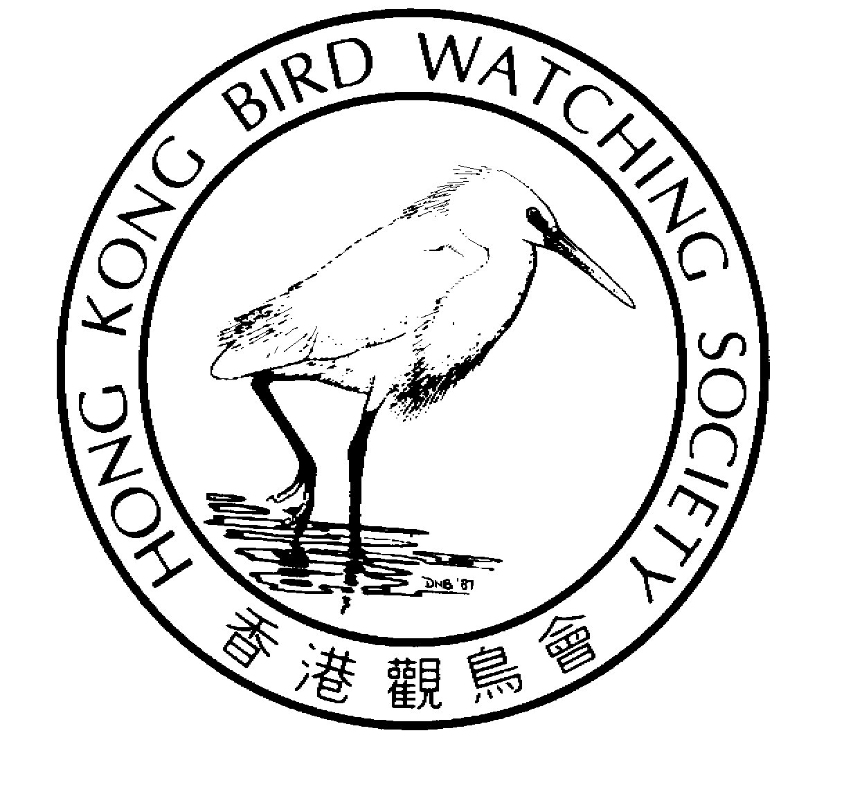


NEWS RELEASE

BirdLife International launches blueprint to halt

Asia’s bird extinction crisis

Highlights importance of Inner Deep Bay for 11 threatened species as new development threats emerge

Tokyo, Japan, 12 November - A ground-breaking guide has been launched for governments and civil society to prevent the extinction of Asia’s birds, one in eight of which is under threat. HIH Princess Takamado of Japan unveiled the blueprint, Saving Asia’s threatened birds, at a ceremony today in Tokyo. [1] The release of the book is extremely timely, coming just days after the announcement by the Hong Kong Government of its support for plans to develop a piece of land surrounded by Inner Deep Bay Important Bird Area.

The book identifies the disturbance or conversion of wetlands, which are crucial for the survival of 20% of threatened species, including the Black-faced Spoonbill, Dalmatian Pelican and Saunders’s Gull as one of the largest threats to Asia’s birds. Inner Deep Bay and Shenzhen River Catchment Important Bird Area is listed for Hong Kong as part of the China Sea Coast section.

Other wetland-dependent species listed for Hong Kong include Styan’s Grasshopper Warbler, Manchurian Reed Warbler, Spoon-billed Sandpiper, and Nordmann’s Greenshank. Chinese (or Swinhoe’s) Egret, Oriental Stork, Baikal Teal, and Baer’s Pochard.

“We welcome the launch of Saving Asia’s threatened birds as wonderful tool. It shows us the bigger picture, demonstrating how birds connect Hong Kong’s important wildlife habitats with other habitats in other ecological regions and countries throughout Asia,” said Mike Kilburn, Chairman of the Conservation Committee of the Hong Kong Bird Watching Society [2]. “More importantly, it highlights Hong Kong’s international responsibilities in protecting threatened species which are just as much a part of the natural heritage of people as far away as Russia, Korea and Australia.”

BirdLife International produced the guide with financial support from the Critical Ecosystem Partnership Fund (CEPF) to help avoid the extinction of 324 threatened bird species, 12% of Asia’s total. [3,4] Already 41 Asian bird species teeter on the brink of extinction, classified as Critically Endangered under World Conservation Union criteria[5]. The strategy provides a holistic solution for the survival of each species, listing necessary conservation measures by 33 priority habitat regions. BirdLife argues that it is best to focus efforts on these threatened habitats because often a single conservation action will address the needs of several threatened species.

At today’s launch, Noritaka Ichida, Director of BirdLife Asia, made recommendations for action which are of conservation importance for a wide selection of Asia’s threatened birds:

- protecting wetlands on the migratory flyways of threatened species, particularly along the coast of the Yellow Sea bordered by China and Korea, and including the Demilitarised Zone between the two Koreas, one of the region’s only remaining wildernesses which should be designated a transboundary peace park;
- conserving the remaining lowland tropical forests in Malaysia and western Indonesia through legislation, land-use planning, sustainable forest management, and support from the private sector;

- conservation measures for key sites for Critical and Endangered Species that are not currently under any protection, particularly in the Philippines and the Maluku region of eastern Indonesia;
- strengthened implementation of the Convention on International Trade in Endangered Species (CITES), given the continued high levels of trade in protected species, especially parrots;
- surveys for ‘lost’ or poorly-known species, before they go extinct, so that conservation measures can be advanced.

“Asia is blessed with a uniquely varied and abundant number of bird species - it is this treasure trove that we are in danger of losing,” says HIH Princess Takamado. “Now, as environmental issues grow into global concerns, it is imperative that we act with intelligent integrity and I am pleased to be a part of the BirdLife Partnership in its efforts to guide the world in this direction.”

“Publishing this document and making it available to governments and other stakeholders is a major step forward for bird conservation in Asia,” says Dr Michael Rands, BirdLife International’s Director and Chief Executive. “Three primary issues highlighted by this strategy fire my determination: The unchecked rapid loss of the Sundaland rainforests of South-East Asia, gaps in Asia’s protected area system for many critically important areas and the trade in wild birds.”

“This strategy launched today clearly articulates a major suite of key actions required to conserve the rarest bird species and most threatened avian habitats in Asia,” says Jorgen Thomsen, CEPF Executive Director and Senior Vice President at Conservation International. “We hope it will be used as a ‘recipe book’ or a route map for designing and implementing more effective conservation actions.”

For further information please contact:
Mike Kilburn, Hong Kong Bird Watching Society Tel: 6221 2984
Carrie Ma, Hong Kong Bird Watching Society Tel: 2377 1864, mobile 9041 3021
Ade Long, BirdLife International in Japan Tel: 03-33-519-981, mobile 08030-051224
E-mail: rg.birdlife@zd.wakwak.com
Gareth Gardiner-Jones, BirdLife International, Cambridge, UK
Tel: + 44 (0) 1223 279 903, 07779 018332 (mobile)
E-mail: gareth.gardiner@birdlife.org.uk.
Photographs of the 11 threatened species at China Sea coast wetland region or other habitat regions will be available from Carrie Ma on request.

BirdLife International press release
http://www.birdlife.org/news/pr/2003/11/asia.html.
Cover of “Saving Asia’s threatened birds: A guide for government and civil society”
http://www.birdlife.org/action/science/species/asia_strategy/index.html
Information about Hong Kong
http://www.birdlife.org/action/science/species/asia_strategy/countries.html
Map of wetland region
http://www.birdlife.org/action/science/species/asia_strategy/wetlands.html

NOTES FOR EDITORS
- Saving Asia’s threatened birds: A guide for government and civil society is available from Natural History Book Services in the UK. Tel: +44(0)1803 865913 - Fax: +44(0)1803 865280. E-mail: sales@nhbs.co.uk.
- HKBWS is affiliate of BirdLife International. BirdLife International is a global alliance of conservation organization working to protect the world’s birds and their habitats. BirdLife International is present in more than 100 countries and territories, with a global membership of over 2,500,000.
- BirdLife International is a global alliance of conservation organisations working in more than 100 countries who, together, are the leading authority on the status of birds, their habitats and the issues and problems affecting bird life.
- CEPF is a joint initiative of Conservation International, the Global Environment Facility, the Government of Japan, the John D. and Catherine T. MacArthur Foundation and the World Bank. CEPF provides funding and technical assistance to civil society groups to help conserve earth’s biologically richest and most threatened areas. CEPF has committed in excess of $29 million to more than 180 conservation projects in Africa, Asia and Latin America.
- BirdLife is the Listing Authority for birds for the World Conservation Union (IUCN) Red List which includes all species judged to be threatened with extinction.

