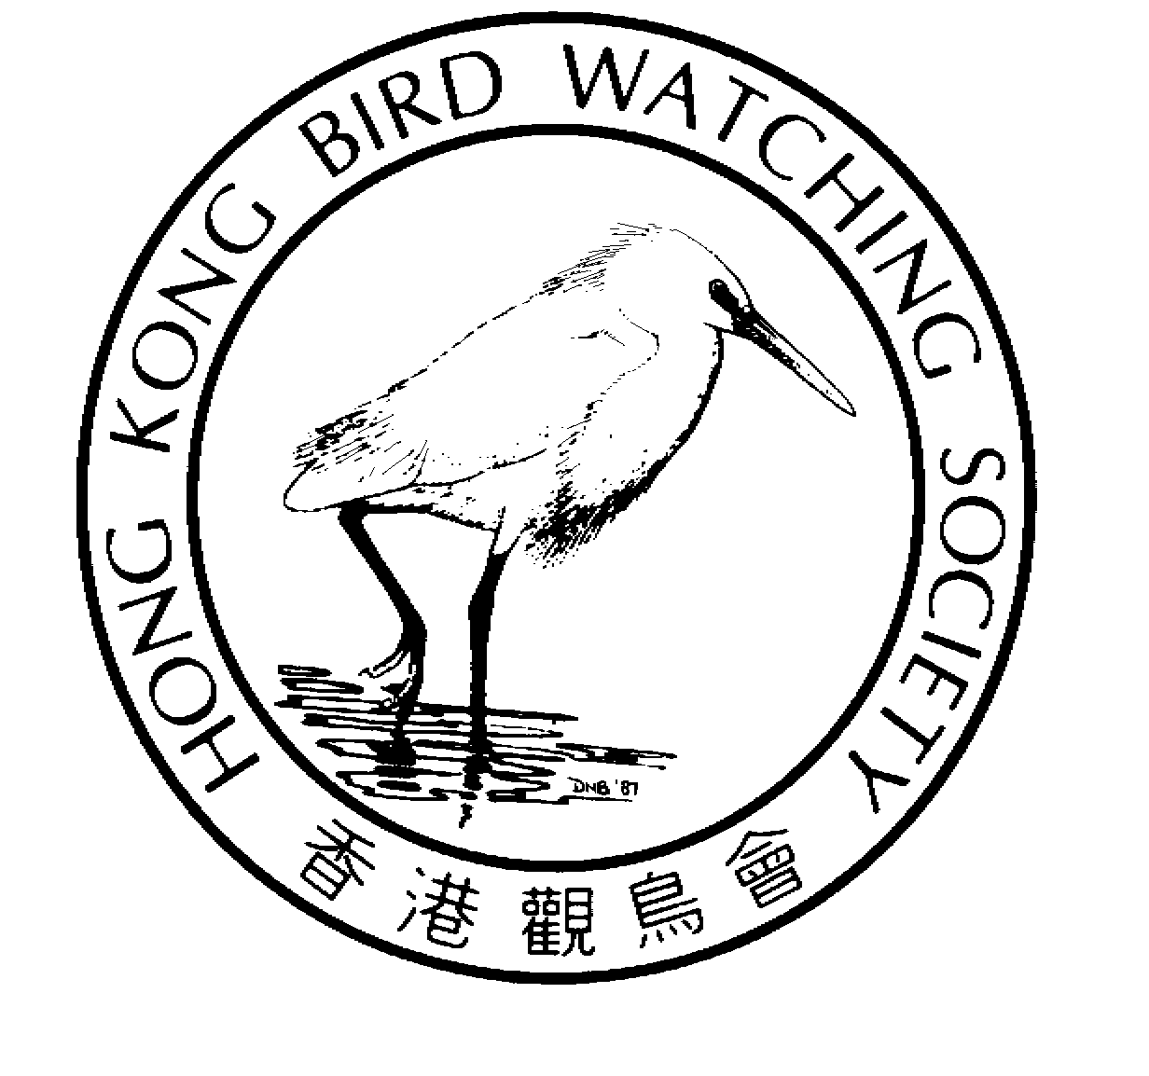
香 港 觀 鳥 會 有 限 公 司
THE HONG KONG BIRD WATCHING SOCIETY Limited
Approved Charitable Institution of Public Character 認可公共性質慈善機構
GPO BOX 12460, HONG KONG. 香港郵政總局信箱12460號

Press Release

Hong Kong Bird Watching Society launches election for

“My Favourite Hong Kong Bird”

18th November 2003. Hong Kong. The Hong Kong Bird Watching Society (HKBWS) today launches the “My Favourite Hong Kong Bird” election. The one-month voting period starts from 19 November. This is the first wildlife election in Hong Kong and members of the public are welcome to cast a vote for their favourite bird species. The campaign aims at promoting among the public a better appreciation of birds and to raise awareness of the beauty and liveliness of Hong Kong’s natural environment.

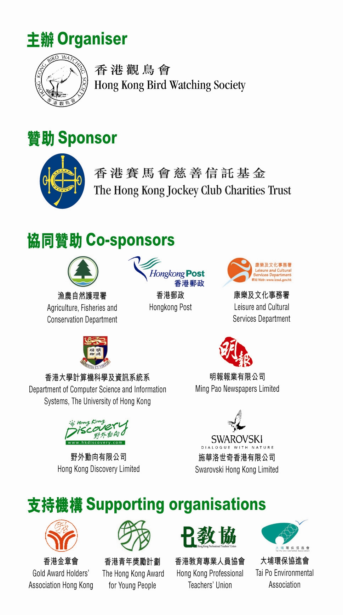
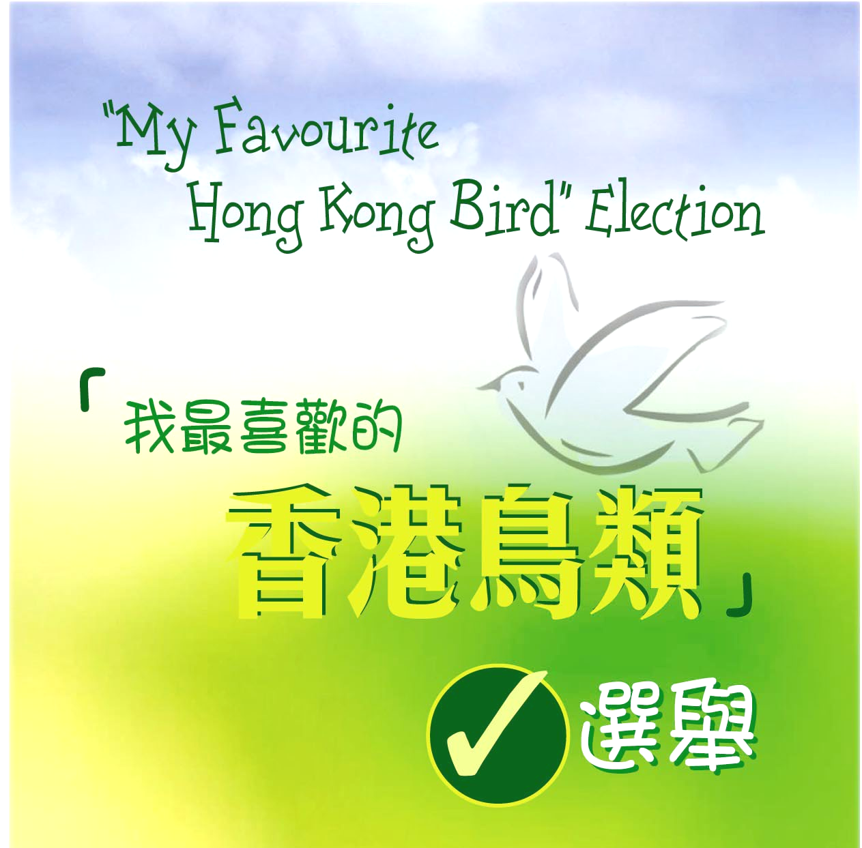
Votes can be cast via the internet on-line or by sending the ballot form. The website address for “My Favourite Hong Kong Bird” election is http://bird.csis.hku.hk/vote/. The relevant information leaflet and ballot form are available at all post offices, visitor centres of country parks, Hong Kong Wetland Park, Hong Kong Park, Kowloon Park, Hong Kong Zoological and Botanical Gardens. It is also published in Ming Pao Daily News and Hong Kong Discovery magazine.

The “My Favourite Hong Kong Bird” election nominates 16 Hong Kong bird species. The information leaflet gives information on their characteristics, size, habitat, etc. Voters will learn more about Hong Kong birds through the voting process and would appreciate more about them if they do make an effort to look for the birds.

At the launching ceremony, the guests cast the first supporting votes ^{[2]}. HKBWS Chairman Lam Chiu Ying, JP said, “Hong Kong is a miracle in the world of birds ^{[1]}. We hope that this election would enable the Hong Kong community to understand and care about our natural treasure. We further hope that everyone would feel happier after noticing the birds one encounters practically wherever they go.” Mr Lam thanked the support of The Hong Kong Jockey Club Charities Trust and added, “The Election is warmly supported by government departments, non-government organizations and commercial enterprises. I am greatly moved by this co-operation, which highlights the point that the Hong Kong people are working together for a better future. “

In order to encourage more people to vote, HKBWS has the support of students of Department of Computer Science and Information Systems of The University of Hong Kong in designing and maintaining the on-line voting system. The website was launched together by HKBWS Vice Chairman Dr Cheung Ho Fai and The Hong Kong Jockey Club Charities Manager Mrs Grace Yeung. It will start operation at 00:00 on 19 November.

“The Hong Kong Jockey Club Charities Trust recognises the importance of preserving the wealth of nature. This project is truly meaningful. It will not only strengthen the public's interest in biodiversity in Hong Kong through birdwatching, but will also help to raise the awareness of conservation.” said Mrs Grace Yeung.

“Indeed, there are many good places in Hong Kong for bird watching, in particular the Mai Po Inner Deep Bay Ramsar Site and Country Parks, where a variety of bird species can be found. Agriculture, Fisheries and Conservation Department is very glad to co-sponsor the Hong Kong Bird Watching Society in the election for “My Favourite Hong Kong Bird”. Through this event, it will help in the promotion of public awareness and appreciation in natural conservation.” said Mr C C Lay, Assistant Director of Agriculture, Fisheries and Conservation Department who was also at the launching ceremony.

The Hong Kong Bird Watching Society is a membership-based organization committed to research, education and the conservation of birds and their habitats. It organizes long-term bird monitoring, runs education activities and promotes the general enjoyment of bird watching. The Society hopes that through bird watching, people would learn to enjoy nature, understand conservation and ecological studies, and appreciate the importance of caring about Hong Kong’s invaluable natural treasure.

– Ends –

Photograph of birds and the launch ceremony of “My Favourite Hong Kong Bird” Election are available on the website: http://www.hkbws.org.hk/fileServer/Projectofficer/election.html.

For further information please contact:
Carrie Ma, Project Officer
Hong Kong Bird Watching Society
Tel: 2377 4387 (office); 9041 3021 (mobile)
E-mail hkbws@hkbws.org.hk

Notes for Editors

^{[1]} Despite its small size (1,000 sq. kilometres) and the image of a bustling international city, Hong Kong is teeming with bird life. Over 450 different species have been recorded here, i.e. about one-third of all the species found in China or one-twentieth of the global number.

^{[2]} Participating organizations include
Organiser:
- Hong Kong Bird Watching Society
Sponsor:
- The Hong Kong Jockey Club Charities Trust
Co-sponsors:
- Agriculture, Fisheries and Conservation Department  - Leisure and Cultural Services Department  - Ming Pao Newspapers Limited  - Swarovski Hong Kong Limited | - Hongkong Post  - Department of Computer Science and Information Systems, The University of Hong Kong  - Hong Kong Discovery Limited
Supporting organisations:
- Gold Award Holders’ Association | - Hong Kong Award for Young People
- Hong Kong Professional Teachers’ Union | - Tai Po Environmental Association

