以下是「我最喜歡的香港鳥類」選舉結果

參與機構包括

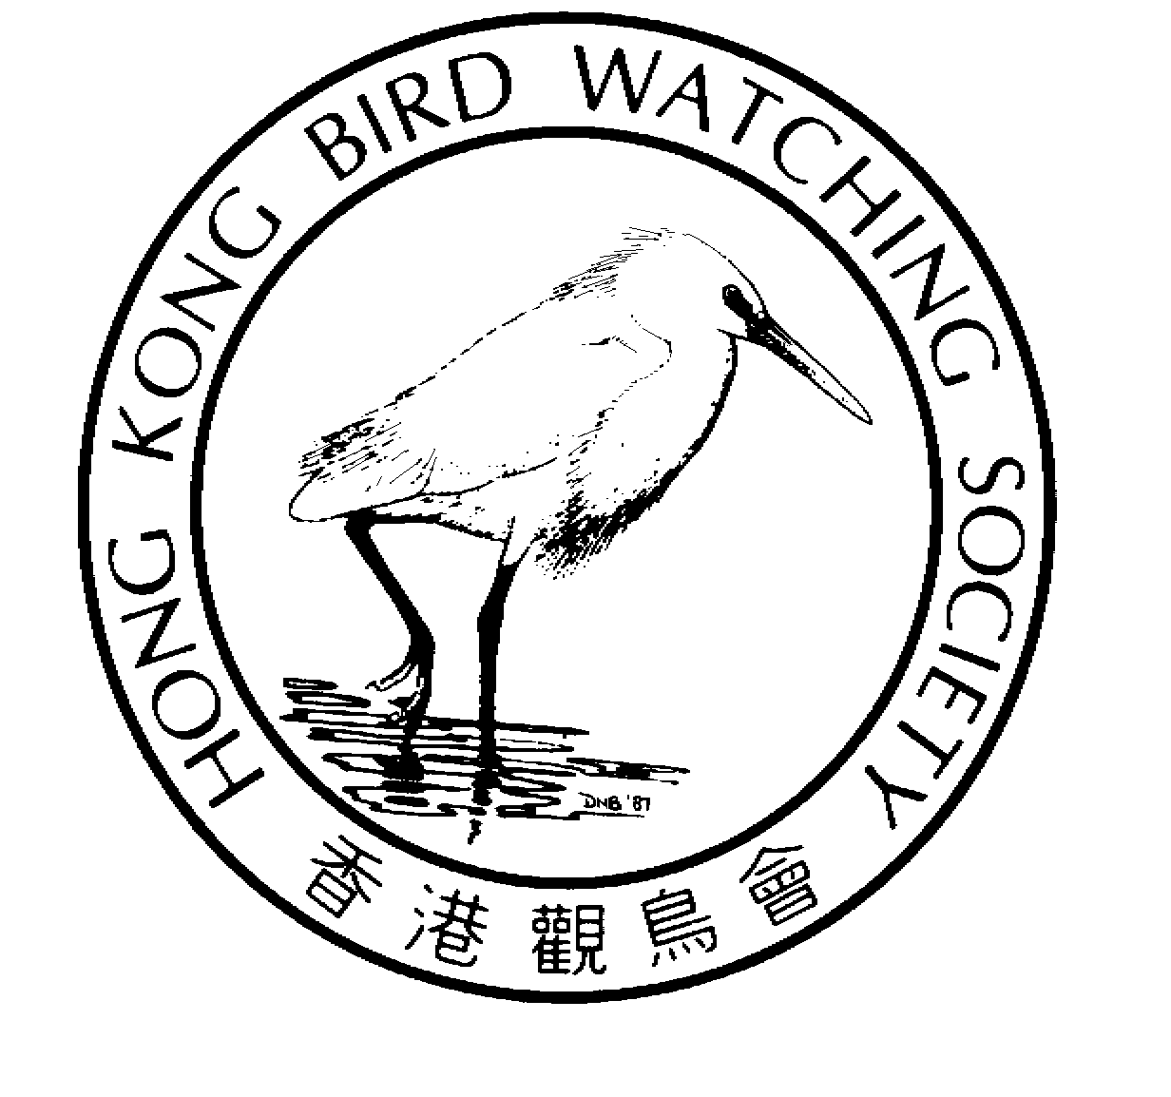
To: Mr C Y Lam
From: Carrie
Alan has helped editing the English version
香 港 觀 鳥 會 有 限 公 司
THE HONG KONG BIRD WATCHING SOCIETY Limited
Approved Charitable Institution of Public Character 認可公共性質慈善機構
GPO BOX 12460, HONG KONG. 香港郵政總局信箱12460號

Press Release

Hong Kong Bird Watching Society announces result of

“My Favourite Hong Kong Bird” Election

Community members join forces to promote awareness of birds and biodiversity in Hong Kong

29th January 2004. Hong Kong. Hong Kong Bird Watching Society (HKBWS) today announces the results of the “My Favourite Hong Kong Bird” election, which was organized by the Society and sponsored by The Hong Kong Jockey Club Charities Trust and with support from other organizations. The campaign is the first wildlife election in Hong Kong – some 25,000 people have voted for their favourite local bird species ^{[1] [3]}.
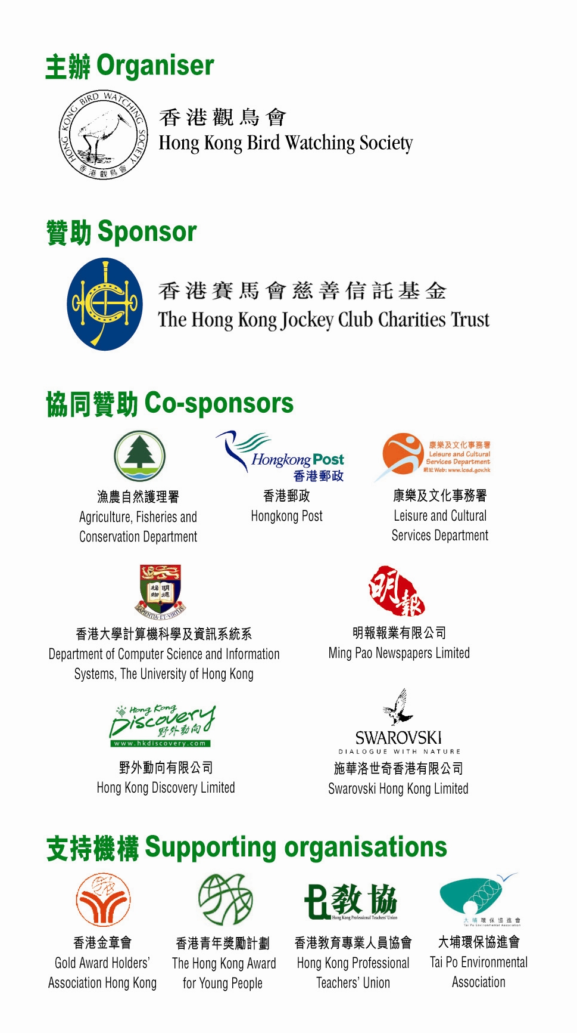
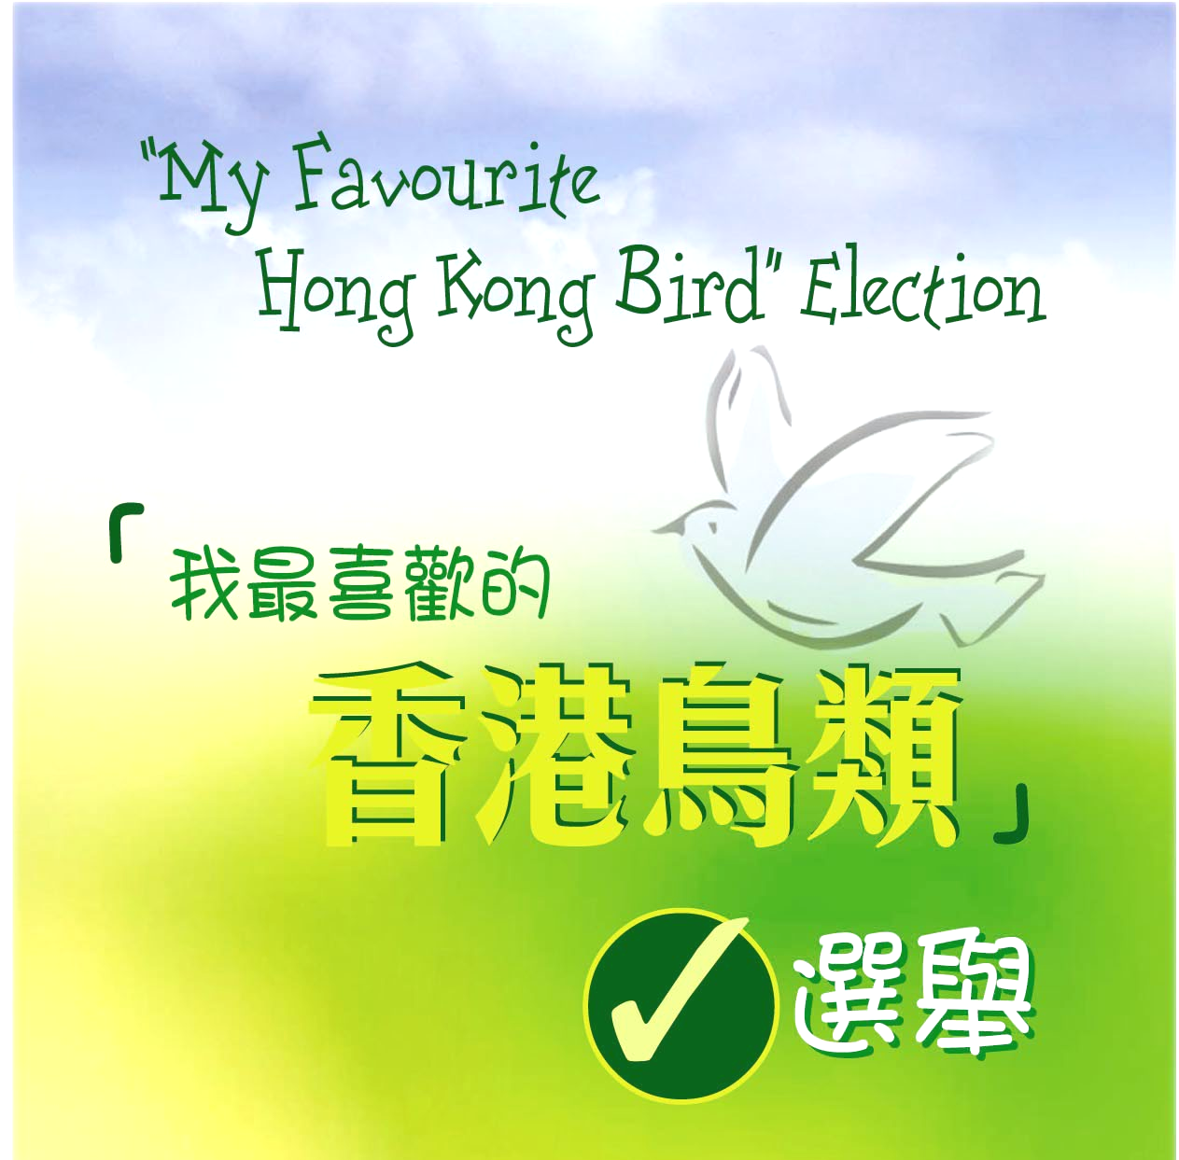
Among the candidates in the election, Tree Sparrow comes first with 4,019 votes or 16% of the total. In addition to its lovely appearance, many Hong Kong citizens consider the bird an “old neighbour” because it is found almost everywhere. Some people also admired its marvellous ability to survive in any environment - a quality that is most valued by the community these days. Finally, the Chinese name for sparrow “ma cheuk”, which has the same pronunciation in Cantonese as the popular game ”mahjong”, makes it all the more familiar and endearing.

Runners up included Little Egret (2,063 votes, 10%), which many people mistakenly call “Crane”; the highly photogenic Common Kingfisher (2,451 votes, 10%); the thumb-sized Scarlet-backed Flowerpecker, which wears a bright red stripe from crown to back (2,226 votes, 9%); Common Magpie (2,061, 8%), which symbolizes good luck; and Fork-tailed Sunbird (1,049 votes, 6%), a tiny creature that is often misidentified as a hummingbird. The fact that these birds are distributed in a wide range of habitats, including urban area, woodlands, coastal area, mangroves, fishponds, farmland, etc., highlights the rich diversity of Hong Kong’s natural environment.

At the ceremony announcing the election results, HKBWS Chairman Lam Chiu Ying, JP said, “The election raises the community’s interest in local flora and fauna and adds a tinge of colour to our daily lives. It also shows that Hong Kong is truly a “City of Life” – among the major cities in Asia, perhaps only Hong Kong is blessed with such a rich variety of wildlife and natural habitats^{[2]}.” Mr Lam thanked The Hong Kong Jockey Club Charities Trust for sponsoring the event. “The election was supported by many government departments, non-government organizations and commercial enterprises. This clearly demonstrates the commitment of the local community to nature conservation.” he added.

Among those who have voted for the winning species, 10 were selected by lucky draw to receive a pair of crystal binoculars from Swarovski Hong Kong Limited. At the same time, HKBWS will also give out more than 500 souvenirs as an encouragement to other voters.

To improve people’s understanding of birds and their habitats, students of the Department of Computer Science and Information Systems of The University of Hong Kong have helped to incorporate detailed information of birds, habitat and birdwatching sites at the voting website at
http://bird.csis.hku.hk/vote/.

“The election has also encouraged citizens to appreciate the "richness" of
the local environment and birds that live there. Agriculture, Fisheries and
Conservation Department is very glad to co-sponsor the Hong Kong Bird
Watching Society in the election for "My Favourite Hong Kong Bird". Through
this event, it helps to raise people's interest in nature conservation” said Mr J K Chan, Senior Wetland and Fauna Officer, Agriculture, Fisheries and Conservation Department.

The Hong Kong Bird Watching Society is an organization run by volunteer members. It is committed to research, education and conservation related to birds and their habitats. The Society organizes long-term bird monitoring schemes, conducts education programmes and promotes appreciation of birds. Through birdwatching, the Society hopes that people will learn to enjoy nature and understand more about conservation, and eventually cultivate care and love for Hong Kong’s priceless natural heritage.

– Ends –

Photographs of the birds and the announcement ceremony of “My Favourite Hong Kong Bird” Election are available at the following website: http://www.hkbws.org.hk/fileServer/Projectofficer/election1.html.

For further information please contact:
Carrie Ma, Project Officer
Hong Kong Bird Watching Society
Tel: 2377 4387 (office); 9041 3021 (mobile)
E-mail hkbws@hkbws.org.hk

Notes for Editors

^{[1]} The final results of the election for “My Favourite Hong Kong Bird” are as follows:
Bird species | No. of votes (Percentage (%)) | Rank
Eurasian Tree Sparrow | 4,019 ( 16) | 1
Little Egret | 2,603 ( 10) | 2
Common Kingfisher | 2,451 ( 10) | 3
Scarlet-backed Flowerpecker | 2,226 ( 9) | 4
Magpie | 2,061 ( 8) | 5
Fork-tailed Sunbird | 1,490 ( 6) | 6
Long-tailed Shrike | 1,456 ( 6) | 7
Chinese Bulbul | 1,442 ( 6) | 8
Magpie Robin | 1,183 ( 5) | 9
Red-whiskered Bulbul | 1,099 ( 4) | 10
Black-capped Kingfisher | 1,052 ( 4) | 11
Black-eared Kite | 934 ( 4) | 12
White-bellied Sea Eagle | 868 ( 4) | 13
Black-faced Spoonbill | 661 ( 3) | 14
Scarlet Minivet | 562 ( 2) | 15
Blue Magpie | 446 ( 2) | 16
Others | 268 ( 1) | --
Total | 24,821 (100)

^{[2]} Despite its small size (only some 1,000 sq. kilometres), Hong Kong is well-known both as an international city and as an important site for migrating birds. Hong Kong has an extremely rich variety of habitats including wetlands, woodlands, streams, shrubland, grassland, hills, cultivated land, open country, coastal area, sea, urban parks, etc. Among the major cities in Asia, perhaps only Hong Kong is blessed with such a diverse in natural environment, which provide living space and food for numerous birds. Over 450 different species have been recorded in Hong Kong - about one-third of all the species found in China or one-twentieth of the global total.

^{[3]} Participating organizations include
Organiser:
- Hong Kong Bird Watching Society
Sponsor:
- The Hong Kong Jockey Club Charities Trust
Co-sponsors:
- Agriculture, Fisheries and Conservation Department  - Leisure and Cultural Services Department  - Ming Pao Newspapers Limited  - Swarovski Hong Kong Limited | - Hongkong Post  - Department of Computer Science and Information Systems, The University of Hong Kong  - Hong Kong Discovery Limited
Supporting organisations:
- Gold Award Holders’ Association | - Hong Kong Award for Young People
- Hong Kong Professional Teachers’ Union | - Tai Po Environmental Association

