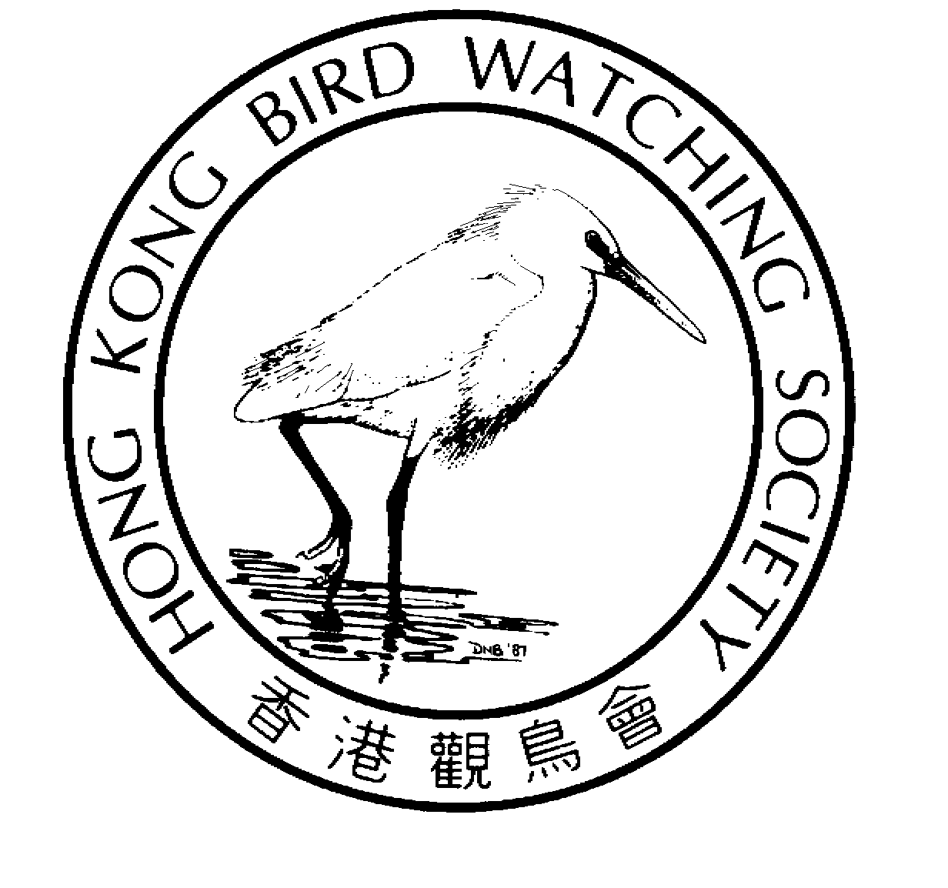
香 港 觀 鳥 會
THE HONG KONG BIRD WATCHING SOCIETY

Attention: News Editors

For immediate release

Hong Kong Bird Watching Society increases Bird List to 465

Records Committee adds 10 new species,

Friday 16th April, 2004. Hong Kong. The Hong Kong Bird Watching Society ^{[1][2]} (HKBWS) today announced the addition of ten new species of wild birds to the avifauna of Hong Kong, bringing the total to 465 species. The decision was announced by Geoff Carey and Cheung Ho Fai of the HKBWS Records Committee.

The ten new species have been added to Category A ^{[3]} of the Hong Kong List, which represents species that have been recorded in an apparently wild state in Hong Kong:

- Red-throated Loon | - Mountain Bulbul
- Malayan Night Heron | - Mountain Tailorbird
- Whooper Swan | - White-spectacled Warbler
- Siberian Crane | - Lesser Whitethroat
- Blyth’s Pipit | - Brown-breasted Flycatcher

(See Appendix A and B for further details of each species)

“Each of these birds has a story to tell – whether its of a lost vagrant far from its normal territory, an expansion of range brought about by improving habitat in Hong Kong, or advances in identification and taxonomy which reveal one species is really a group of several very similar species,” said Cheung Ho Fai “And each bird also represents a magical moment – like winning Mark Six - for each of the bird watchers who realised he is looking at or taking a picture of a bird never before seen in Hong Kong.”

Bird watchers in Hong Kong have built a good network for sharing news about such exciting discoveries, so that up-to-date bird watching information is readily available by



telephone hotline and through the Website BBS ^{[4]}. Hong Kong is among the best-monitored places in South-east Asia.

“Adding new species to the SAR list is one of the most exciting aspects of birdwatching in Hong Kong, “said Geoff Carey. “However, before any record is approved it must be rigorously checked to ensure that the bird in question has been correctly identified and that the likelihood that it is not a truly wild bird has been eliminated.”

“Some of the most complex and difficult decisions of the Records Committee are related to assessing the status of birds which appear to be wild,” noted Cheung Ho Fai. “Owing to the heavy bird trade and the large numbers of birds freed for religious purposes, many supposedly wild birds have been brought to Hong Kong by people, and cannot be considered truly wild in Hong Kong.”

The authority on birds since 1957

HKBWS has kept the official record of the birds of Hong Kong since its foundation in 1957, and it remains the sole authority on birds in Hong Kong. This authority stems from the fact that HKBWS has compiled records of birds stretching back to 1860 and has accumulated 47 years of continual systematic records since the Society’s establishment.

The HKBWS Records Committee is responsible for compiling, assessing, reviewing and publishing all bird records submitted to the Society. These publications include the annual “Hong Kong Bird Report” and “The Avifauna of Hong Kong”, the standard work on the birds of Hong Kong, published by HKBWS in 2001.

This committee is comprised of five of Hong Kong’s most dedicated, knowledgeable, and experienced bird watchers, who together have accumulated more than 120 years of combined experience in identifying, recording and studying birds. The peer-review of records ensures that all information on birds published by HKBWS is of a uniformly high standard, which is respected by ornithologists around the world.

Established guidelines for submitting records

Every bird record is submitted by an individual (usually a HKBWS member), who simply fills in a simple spreadsheet which can be downloaded from the HKBWS website.

However, the Records Committee has prepared carefully considered guidelines for submitting records of rarer species (Appendix C).

In the case of species new to Hong Kong a much higher standard of evidence is required before the record can be accepted. In this case a full description, preferably supported by sketches, photos and even sound recordings may be required to confirm both the identity and the genuinely wild status of the bird.

- Ends -

For further information, please contact:

Carrie Ma, Project Officer, Hong Kong Bird Watching Society
Tel: 2377 4387
Email: hkbws@hkbws.org.hk
Website: www.hkbws.org.hk

Notes to Editors

[1] The Hong Kong Bird Watching Society is an organization run by volunteer members. It is committed to research, education and conservation related to birds and their habitats. The Society organizes long-term bird monitoring schemes, conducts research and education programmes, promotes appreciation of birds, and builds community participation.

[2] HKBWS is affiliate of BirdLife International. BirdLife International is a global alliance of conservation organization working to protect the world’s birds and their habitats. BirdLife International is present in more than 103 countries and territories, with a global membership of over 2,500,000.

[3] According to the “Avifauna of Hong Kong” published by HKBWS, the status of birds of Hong Kong is defined as:
Category A: Species that have been recorded in an apparently wild state in Hong Kong.
Category B: Species that are considered to have probably occurred in Hong Kong in a wild state, but for which the possibility of escape or release from captivity cannot be satisfactorily excluded.
Category C: Southeast China breeding species, the established or formerly established Hong Kong population of which is considered to be derived from captive stock, but which probably occurred in Hong Kong prior to anthropogenic habitat changes.
Category D: Extralimital species originally introduced to Hong Kong by man that maintain, or did maintain, a regular feral breeding stock without necessary recourse to further introduction.
Category E: Species for which all published Hong Kong records are considered likely to relate to birds that have escaped or have been released from captivity.
Category F: Species for which all published Hong Kong records must be regarded as doubtful because of the possibility of mistaken identification.

[4] BirdLine: Cantonese: 2465 6690; English: 2667 4537
Bulletin Board (BBS) http://www.hkbws.org.hk

Appendix A

Additions to the Hong Kong List: Category A
Species that have been recorded in an apparently wild state in Hong Kong

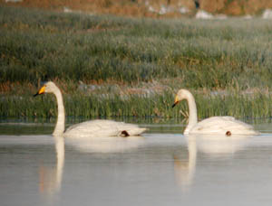
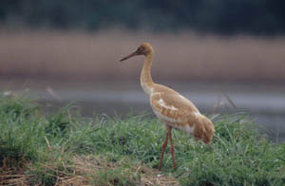
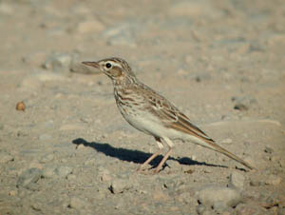
© Cheung Ho Fai
© Chiang Ming-Liang

1. Red-throated Loon Gavia stellata

One at Starling Inlet, 18 February 2002.

An oil-stained bird was found at Starling Inlet on 18 February and taken into care by the Agriculture, Fisheries and Conservation Department. After being cleaned it was released two days later. Breeding in Siberia, and occurs as a migrant and winter visitor to coastal waters of east and southeast China.

2. Malayan Night Heron Gorsachius melanolophus

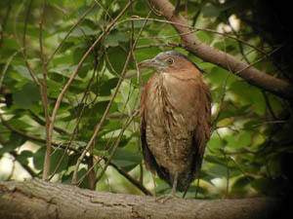
Two birds were photographed by the Wildlife Conservation Foundation using remote sensing camera in woodland at Lo Kei Wan, Lantau on 19 April 2003.
© Chiang Ming-Liang

Malayan Night Heron occurs from India, Yunnan, Guangxi, Hainan, Taiwan, Philippines, Burma, Thailand, and Malaysia. Committee members also noted that the date and the presence of two birds indicate possible breeding.

3. Whooper Swan Cygnus cygnus
An adult at Mai Po on 13 March 2001.

Whooper Swan breeds across the entire northern Palearctic and in China regularly winters as far south as the Yangtze River.

4. Siberian Crane Grus leucogeranus
A juvenile was at Mai Po on 11th and 12 December 2002.

Breeds Siberia, and winters largely in central China in the Yangtze floodplain. This is the first record of this spectacular species on the south China coast.
© Anthony Lo

5. Blyth’s Pipit Anthus godlewskii

Kam Tin, 8 to at least 10 October 2002.This bird occurred during a period of particularly heavy migration and coincided with the first Hong Kong record of Lesser Whitethroat and the fourth record of Rose-coloured Starling.

Breeding in Mongolia and adjacent parts of Russia and China, it winters mainly in India.

6. Mountain Bulbul Hypsipetes mcclellandii
Up to two birds in Tai Po Kau on 7th and 29 January 2002. Birds were also present in Tai Po Kau during winter 2002-03 and 2003-04.

Mountain Bulbul occurs throughout much of China south of the Yangtze, including Guangdong.

7. Mountain Tailorbird Orthotomus cucullatus
One at Tai Po Kau on 8th and 9 October 1999, as well as a series of records in subsequent winters at widespread localities in the northern and eastern New Territories.

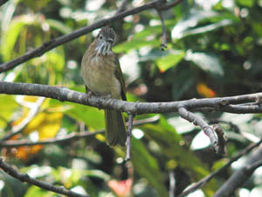
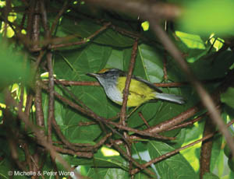
In addition to having been recorded in Guangdong at many sites, one was also seen at Wutong Shan, near Shenzhen on 17 May 2001.
© Cheung Ho Fai
© Peter and Michelle Wong

8. White-spectacled Warbler Seicercus affinis

One was photographed in Tai Po Kau on 31 January 2003.

Breeds from eastern Nepal through to southern China, northern Laos and southern Vietnam. Winters at lower elevations, including Guangdong Province.
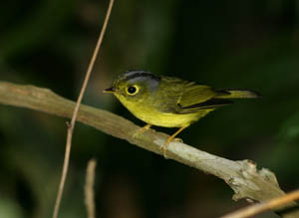
© Peter and Michelle Wong

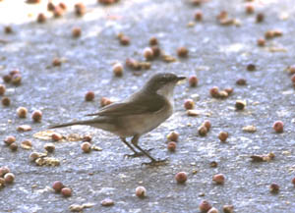
9. Lesser Whitethroat Sylvia curruca
© Yu Yat Tung
One was seen and photographed at Long Valley on 9 October 2002.

This species breeds from Europe across to Central Asia and southern Siberia, and winters in Africa and India.

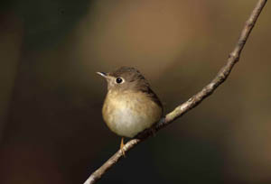
10. Brown-breasted Flycatcher Muscicapa muttui
A well-watched and well-photographed bird was at Tai Po Kau from 28 November 2001 to at least 21 January 2002.

Brown-breasted Flycatcher occurs from India, Burma, Yunnan, Sichuan, Gansu, Guizhou, and Guangxi.
© Anthony Lo

Appendix B

Additions to the Hong Kong List: Category E

Species for which all published Hong Kong records are considered likely to relate to birds that have escaped or have been released from captivity

1. Great White Pelican Pelecanus onocrotalus
One was at Mai Po and Deep Bay from 15 December 2002 to at least 22 February 2003. However, this bird had damaged wings indicating it was an escape from captivity. A pelican was reported missing from Hong Kong Park in early December 2002, and it is likely that it was this bird that subsequently occurred in Deep Bay.

2. Greater White-fronted Goose Anser albifrons
One found at night at Discovery Bay on approximately 16 October 1999 and taken into care at Kadoorie Farm and Botanic Garden on 20th, was subsequently released at the Mai Po Nature Reserve Waterfowl Collection on 22 November 1999, where it remained for some time.

The behaviour of this bird subsequent to release at Mai Po, where it remained with captive geese, and the relatively northerly distribution of records in China indicate this bird was probably of captive origin.

The species breeds in Greenland, Russia, Siberia, Alaska and Canada, and is a migrant and winter visitor to northeastern and eastern China.

3. Eurasian Collared Dove Streptopelia decaocto
One was seen near Mai Po on 29th April 1999, and many further records occurred during 1999 – 2004.

Collared Dove has an extensive native range across the Palearctic and Oriental Regions. At present these birds are considered to have derived from birds of captive origin, as despite the westward spread in Europe, there is no evidence of the natural range of this species spreading in China, birds are frequently kept in captivity and feral populations are known.

4. Bearded Reedling Panurus biarmicus
One male trapped at Mai Po on 22 December 2002. However, with the closest populations having a natural range lying largely north of the Yellow River, natural occurrence is considered extremely unlikely.

Appendix C

Guidelines for the submission of Records

  - Record submission form also available for download at HKBWS website:
  - http://www.hkbws.org.hk/record.html (English)
  - http://www.hkbws.org.hk/recordc.html (Chinese)
  - See Page 8 to 9 for details of submission of rarity Records

Field notes for submission of rarity record:

- Date, time and location of sighting.
- Power of bionocular/telescope used, distance of birds form the observer, weather and light conditions.
- Description of habitat and what other birds, if any, it was association with.
- Angle of view and actions: at rest, in flight, swimming etc. The more varied the conditions the better.
- Its general size, shape and structure compared with other more familiar species. Structural features that may be important should be detailed e.g. bill length compared to length of head; relative position of wing tips to uppertail coverts; projection of primary tips beyond closed tertials; length of hind claw etc.
- The most details description possible of the plumage and bare parts, and not just those parts thought to help in identification. This description should be logical and organized, and the following sequence is suggested:
  - head
  - upperparts
  - wings, including underwing if seen
  - tail, both upper and lower sides
  - underparts
  - bare parts (iris, bill, gape if seen, legs and feet)
- Any calls, indicating especially the quality of sound (harsh, rattling, shrill, horarse, liquid etc.) and comparison with calls of other species.
- Notes on previous experience with the species or species with which it may be confused.
- Names of other observers present, if any.

