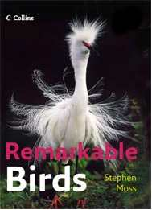
Remarkable Birds

Collins is publishing a book of the world's must-see birds, and would like your help to decide which species should be included, by answering the four questions below. In return for your help, we will send you a copy of the book on publication, and you will automatically be entered into a prize draw to win £250 worth of Collins books. The winner will be announced at the end of May.

Name
Address

- Which region of the world do you live in?

- Europe and the Middle East
- North America (including Mexico)
- South America, Central America and the Caribbean
- Africa
- Asia
- Australasia and the Pacific

2. Which 10 species of birds in your region do you consider ‘unmissable’? Your choice may include – but not be limited by – species that are:
- Iconic
- Unique
- Highly sought-after by visiting birders
- Your personal favourites

1
2
3
4
5
6
7
8
9
10

- Of your list above, which bird is your personal favourite, and why (ideally in 50 words or less!)?

4. Are there any other birds outside your region that you consider ‘unmissable’, and why should they be included?

Please send your answers to birds@collins.co.uk by 20 May 2006. Alternatively you can post them to The Editorial Director, Collins Natural History, 77-85 Fulham Palace Road, London, W6 8JB

