”Keeping Asia's Spoonbills Airborne”
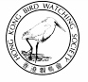 | Organized by  The Hong Kong Bird Watching Society  香港觀鳥會
Sponsored by
The Croucher Foundation
裘槎基金會
Environment and Conservation Fund
環境及自然保育基金
Environmental Campaign Committee
環境保護運動委員會

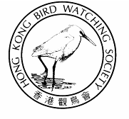

International Symposium on Research and Conservation of the Black-faced Spoonbill
”讓 亞 洲 的. 琵 鷺 繼 續 翱 翔”
黑臉琵鷺研究和保育國際研討會


The globally threatened Black-faced Spoonbill is the flagship for waterbirds and wetland conservation across the Asia region. It's known population is about 1,400 and it is globally endangered. To concentrate the effort to protect the endangered Black-faced Spoonbill and their natural environment, Hong Kong Bird Watching Society is organizing a 3-days international symposium in 16-18 January 2006.
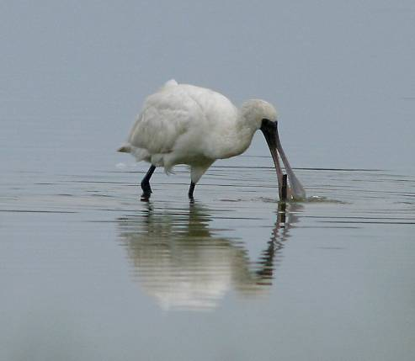
The highlight of the symposium will be providing a discussion platform to review existing information, to strengthen research efforts and to streamline conservation efforts to protect the species and their natural wetland habitats. With the support from BirdLife Asia Division, the symposium will also review the Action Plan for future conservation of the Black-faced Spoonbill, and among their habitats along the flyway. We expect to achieve this by facilitate information exchange among spoonbill experts and conservationist of the main natural range of Black-faced Spoonbill, including Korea, N. Korea, Japan, mainland China, Taiwan, Hong Kong, Macao and Vietnam.
YOU are welcome to participate in the Symposium, especially the public forum on 18 January 2005 at 7:00 pm in The Hong Kong Observatory.
© Henry Lui
Supporting Organizations 合作機構：
BirdLife International Asia Division
國際鳥盟亞洲分部
Agriculture, Fisheries & Conservation Dept
漁農自然護理署
World Wide Fund (Hong Kong)
世界自然（香港）基金會
Kadoorie Farm and Botanic Garden
嘉道理農場暨植物園

黑臉琵鷺是亞洲地區水鳥及濕地保育的指標鳥類。現時全球有1,400只黑臉琵鷺，屬瀕危鳥種。為了集中保育的力量，香港觀鳥會將於2006年1月16-18日舉行為期3天的國際研討會。
是次國際研討會將提供一個交流平台，報告和覆核琵鷺紀錄，加強集中保育力量，從而達到保護這鳥種以及牠的生境。香港觀鳥會獲國際鳥盟亞洲分部支持，將會於是次研討會討論最新的「黑臉琵鷺保育行動綱領」，作為將來保育琵鷺以及牠們棲地的重要依據。我們預期是次研討會將促進各地專家互相交流，參與者包括來自韓國、朝鮮、日本、中國大陸、台灣、香港、澳門和越南等地的琵鷺專家和保育工作者。

我們誠意邀請 閣下出席，特別是於一月十八日晚上七時於天文台舉行的公眾論壇。

International Symposium on Research and Conservation of the Black-faced Spoonbill

Date: 16-17 January 2006
Time: 8:30 am – 6:00 pm
Venue: Rm 1106, Scout Association of HK, Kowloon
Language: English
Registration Fee: HK$450
Public Forum: Conservation of the
Black-faced Spoonbill

Date: 18 January 2006
Time: 7:00 pm – 8:30 pm
Venue: Conference Room, HK Observatory, TST
Language: Chinese and English
Registration Fee: Free

REGISTRATION 登記表格

Please register to let us by fax or e-mail 登記可以傳真或電郵方式 (Fax：2314 3687 , E-mail: hkbws@hkbws.org.hk)
Cheque (Payable to “The Hong Kong Bird Watching Society Limited”) should be sent with this form to our office by mail.

I wish to attend the ◻ International Symposium ◻16/1/05 ◻ 17/1/2005
(please ✓) ◻ Public Forum 18/1/2005

Name 姓名:______________________ Contact No.聯絡電話.: ______________ E-mail電郵: ________________________________

Address地址:__________________________________________________________________________________________________

The Hong Kong Bird Watching Society Limited 香港觀鳥會有限公司 Fax: 2314 3687 Tel: 2377 4387
Room 1612 Beverley Commercial Centre, 87-105 Chatham Road, Tsim Sha Tsui, Kowloon, Hong Kong

