Invitation to meet Dr Jane Goodall Face-to-face in Hong Kong!
27 November 2004, Saturday

R.S.V.P. to: (fax) 2357-1670 or toby@janegoodall.org.hk
Before 24 November 2004, i.e. Next Wed

REPLY SLIP

I would like to attend (please ✓):

- School Talk at Baptist Rainbow Primary School (09.00-10.15 hours).
Please reserve ___________ seat(s) (please specify).

- Public Lecture at The University of Hong Kong (14.00-17.00 hours).
Please reserve ___________ seat(s) (please specify).

Contact Person :
Organization/School :
Contact Number :
Email :

The Jane Goodall Institute Hong Kong
Tel: 2191-3007
Fax: 2357-1670
Email: info@janegoodall.org.hk
Address: Flat 804, 8/F, Shiu Fat Industrial Building, 139-141 Wai Yip Street, Kwun Tong, HK.
(1) Baptist Rainbow Primary School, Chuk Yuen Road, Wong Tai Sin, Kowloon. Tel: 2328-7971
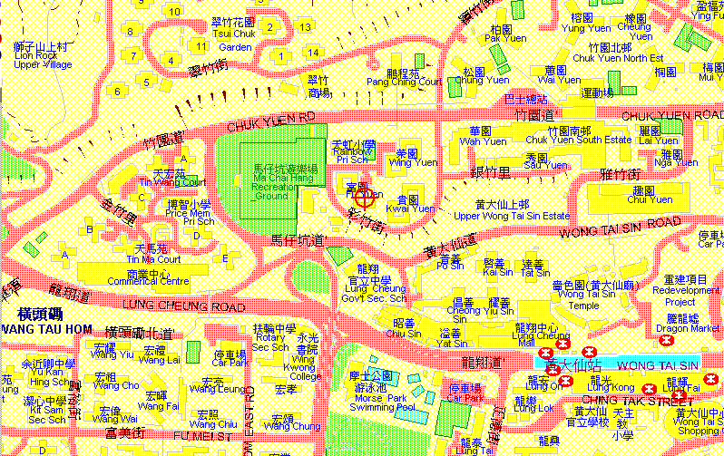

(2) P4 Theatre, Chong Yuet Ming Physics Building, The University of Hong Kong, Pokfulam.
