Waterbird Count
Organized by
The Hong Kong Bird Watching Society
香港觀鳥會策劃
Sponsored by
Agriculture, Fisheries and Conservation Department
漁農自然護理署資助

Training Workshop
水鳥普查訓練工作坊
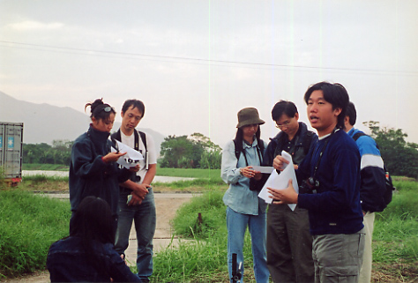
The Waterbird Monitoring Programme is an integrated professional programme coordinated and reported by HKBWS. The Waterbird counts began at 1979. Since 2000, this project was supported by Agriculture, Fisheries and Conservation Department.

This is one of the largest programme of the Society with more than 30 active volunteers contributing their time, carrying out bird survey throughout the year, to collect population data at species level. The programme consists of three parts (1) Monthly Waterbird Surveys; (2) Shorebird Surveys and (3) Egretry Counts. These data are essential for monitoring the value of wetlands, endangered species, population and environmental changes. It forms an important component of the conservation and management of the Mai Po Inner Deep Bay Ramsar Site.

The “Waterbird Count Training Workshop” is an annual event designed to allow more member to participate in waterbird count. It is a good opportunity chance to learn the techniques required for waterbird counting at the Mai Po Inner Deep Bay area, plus, of course, the satisfaction of contributing to the conservation and management work of the Ramsar Site.

All members are welcome to join, the basic requirement being some knowledge with the common waterbirds in the Deep Bay area.

水鳥普查是香港觀鳥會策劃、推動及定期匯報調查結果的專業項目。這項目於一九七九年展開，二零零零年起，獲漁農自然護理署資助進行。
Programme highlights include:
- History of waterbird count in Hong Kong;
- Techniques of bird counting and habitat monitoring;
- Counting of roosting cormorant at Mai Po

活動重點：
- 了解香港水鳥普查的歷史
- 野外實習水鳥和生境調查
- 在米埔點算鸕鷀

Bring your binoculars
請自備雙筒望遠鏡

是項全年性的普查由三十多位資深鳥友於工餘時間協助進行，收集各鳥種數量資料。普查項目包括(1)每月水鳥普查；(2)遷徙水鳥統計以及(3)白鷺林統計。這些數據正是監察濕地的變遷及其瀕危品種和數量的改變的重要基礎資料。同時亦成為管理及保育內后海灣國際重要濕地的重要部份。

「水鳥普查訓練工作坊」是本會一年一度舉辦的訓練項目，目的是讓更多鳥友認識鳥類普查的技巧，並鼓勵及提升更多鳥友參與水鳥普查工作。更重要的是，讓大家直接參與和貢獻在國際重要濕地的保育和管理工作，從而獲取更大的滿足感。

歡迎會員參與「水鳥普查訓練工作坊」，不過條件是：會員必須認識后海灣常見的濕地鳥類！

Waterbird Count Training Workshop (Half day) |  | 水鳥普查訓練工作坊 (半天活動)
20 January 2008 (Sunday) |  | 2008年1月20日(星期日)
9:00 am – 12:30 noon |  | 上午 9:00至中午 12:30
Mai Po Car Park |  | 米埔停車場集合

registration is free – but space is limited 費用全免，名額有限

REGISTRATION 登記表格

Please register to let us by fax or e-mail 登記可以傳真或電郵方式 (Fax：2314 3687 E-mail: hkbws@hkbws.org.hk)
I wish to attend the Waterbird Count Training Workshop on 20 January 2008
我想參加2008年1月20日的水鳥普查訓練工作坊

Name 姓名:__________________________ Contact no聯絡電話.: ______________ E-mail電郵: ____________________

Address地址:__________________________________________________________________________________________

Hong Kong Bird Watching Society 香港觀鳥會
Room 1612 Beverley Commercial Centre, 87-105 Chatham Road, Tsim Sha Tsui, Kowloon, Hong Kong

