For more details, you can visit the following webpage:
http://www2.netvigator.com/services/techsupp/bb/settings/upload_ftp.html

As you are using Netvigator.com, just type "ftp://one4all.netvigator.com" at I.E. browser and then using your user name and password to login.
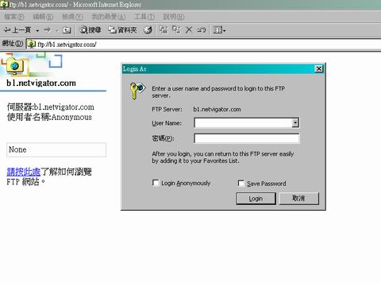
Your files need to be stored inside a folder called “public_html” . You can use the command "mkdir" to create the directory with your FTP client or you can submit the following form to NETVIGATOR. This form will automatically create a public_html directory in your Internet Account.
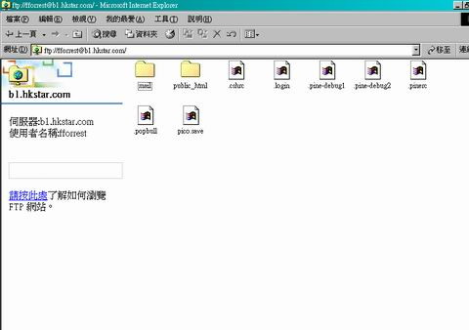

Photo files can be added/deleted/renamed in the "public_html" folder as in any file folder.
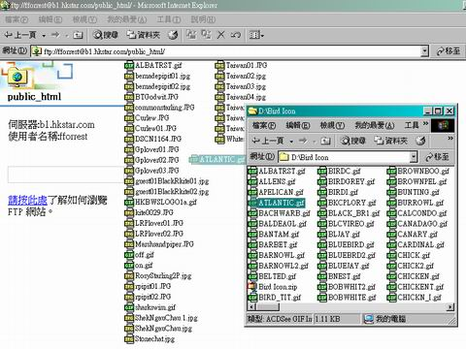
After uploading all the photo files to the :public_hmtl" folder, please type "http//home.netvigator.com/~user name/" at I.E. Then you will reach the index page of your file server.
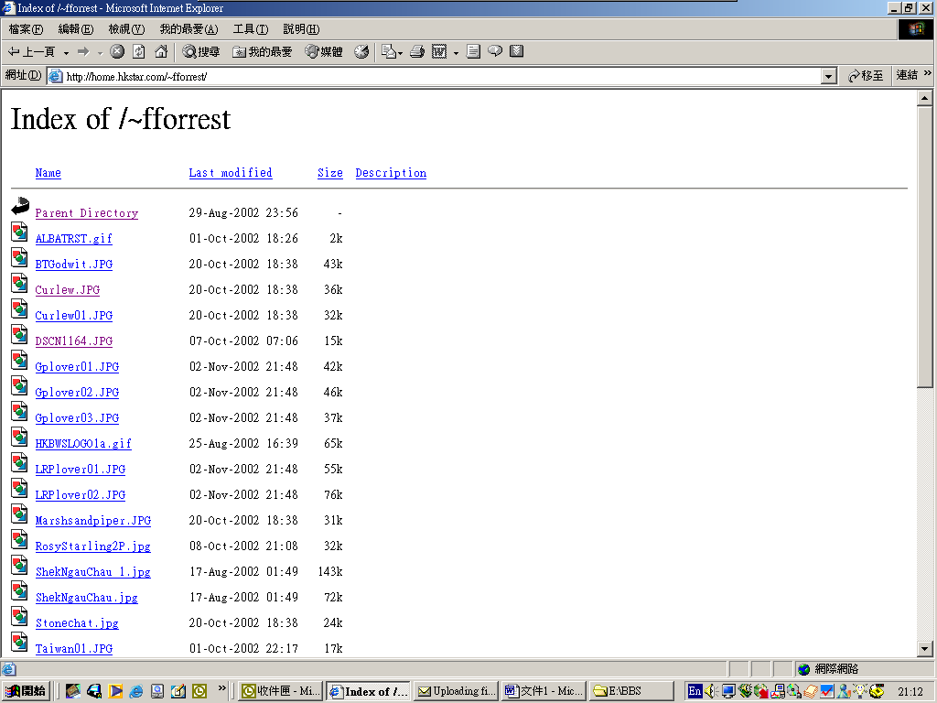

By double-clicking the photo file, your photo and its URL are displayed. Be careful, all the files stored in this folder can be accessed by other people. 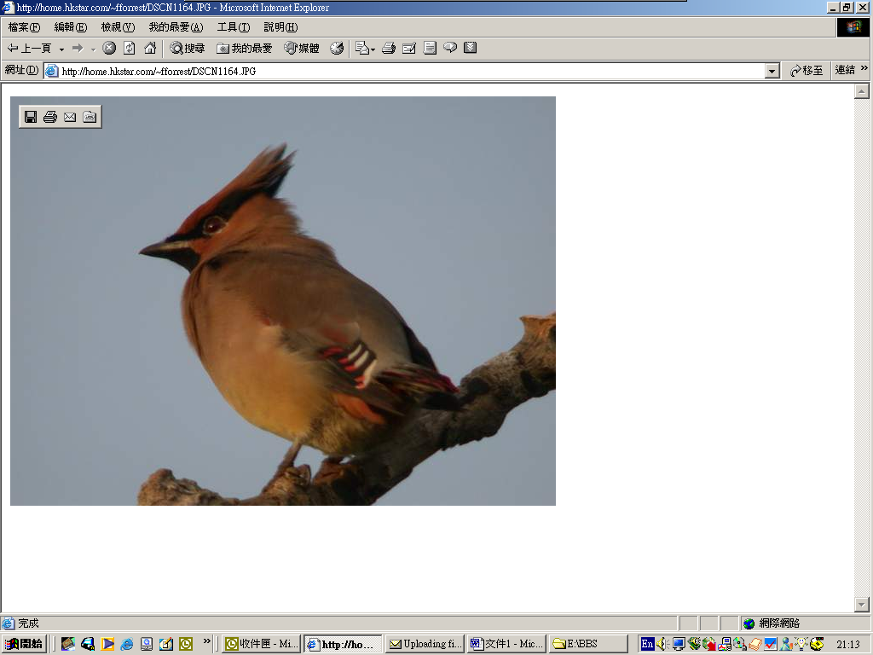
Don't store more than 5M of files in your ISP server, otherwise you will be charged for additional fee about HK$20 per 1M per month.

